**Viking Bot 2.0 Instruction Guide**

This guide is intended to help the user take an inexpensive “Viking Bot” and turn it into a robust and modular platform for robotics projects.

**Need for an updated “Viking Bot”**

Learning about robotics is becoming easier. There are many tools and tutorials available and the cost of beginner “robots” is very low. That’s why the simple robot car kits available on Amazon or Ebay can be had for as little as $12. These cars were used in our robotics class as [braitenberg](https://www.google.com/search?rlz=1C5CHFA_enUS869US869&q=braitenberg+robots&sa=X&ved=2ahUKEwjkk6KN5KnmAhXeFzQIHYpyAVQQ7xYoAHoECAwQJg) vehicles for many projects. However, they always needed to be modified to allow them to function in repeatable ways. We decided to take what we have learned hacking together a usable robot from these inexpensive kits and codify it into its own project. This way other groups can get a faster start on a cheap bot with more battery life, proper power for a microcontroller, and a modular design to mount extra accessories as they advance their skills.

**Getting Started**

To get started, you’ll need to purchase a few things. Below is a list of parts we’ve found to work well together. They are all available on Amazon, but you can feel free to substitute as needed from your personal supplies or parts that are available locally.

[Robot car kit](https://www.amazon.com/s?k=arduino+robot+car&ref=nb_sb_noss_1) (very inexpensive, and gives you many of the basic parts)

[Raspberry Pi 3B+](https://www.amazon.com/s?k=raspberry+pi+3+B%2B&ref=nb_sb_noss_2) (Or similar microprocessor, microcontroller, etc)

[Micro USB cable](https://www.amazon.com/s?k=micro+usb+cable&ref=nb_sb_noss_2) (Cheap charge only is fine, we’re cutting it apart)

[Rechargeable 18650 Batteries](https://www.amazon.com/s?k=18650+batteries&ref=nb_sb_noss_1) (I like the samsung batteries best)

[18650 battery holders](https://www.amazon.com/s?k=18650+battery+holders&ref=nb_sb_noss_1) (The 3 battery holders get you to 12V)

[18650 battery charger](https://www.amazon.com/s?k=18650+battery+charger&ref=nb_sb_noss_2) (Get a decent charger to safely charge your batteries)

[Voltage regulator](https://www.amazon.com/Converter-DROK-Voltage-Regulator-Waterproof/dp/B07P663XJV/ref=sr_1_9?crid=387URND403Y7L&keywords=drok+voltage+regulator&qid=1575946652&sprefix=drok+voltage+re%2Caps%2C183&sr=8-9) (used to get 5V 3A from batteries for Pi)

[12 x 12 acrylic sheet](https://www.amazon.com/s?k=12+x+12+acrylic+sheet&ref=nb_sb_noss_2) (for laser cutting your new platform)

[Motors and Wheels](https://www.amazon.com/280RPM-25GA370-Encoder-Mounting-Bracket/dp/B07NYXR1VM/ref=sr_1_23?keywords=robot+car+motors&qid=1575945522&sr=8-23) (You don’t need these, but they are better than kit versions)

**Cut out your new platform (Optional)**

You can use the platform that comes with your kit instead of cutting a new platform. However, we found that it was very limiting with where we could mount hardware and how much space we had to place our equipment. Inspired by the modularity of the turtlebot, we made this platform so we could have more space, use bigger motors, and add standoffs for stacking platforms. If you don’t have access to a laser cutter, you could also use this as a template and cut it from wood with a bandsaw. Then you could use a drill to make the hole pattern.

See the hardware section for design files.

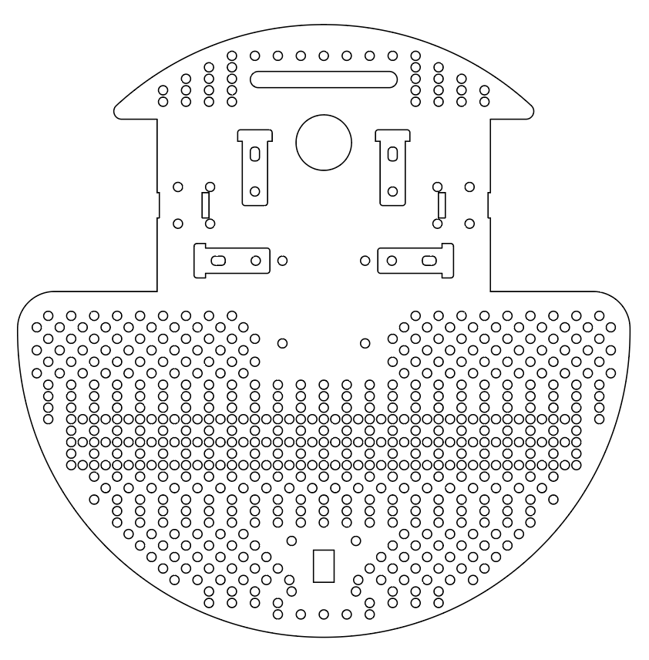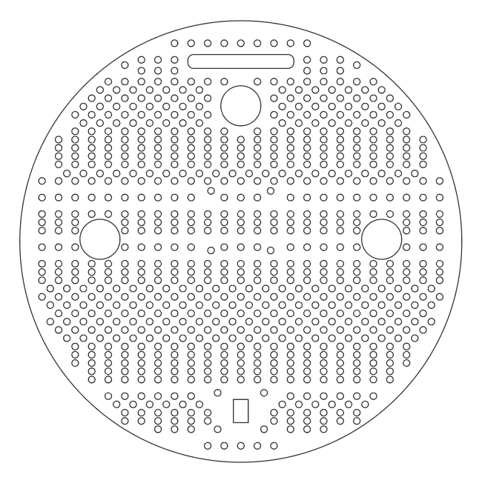

**Start Building the Structure**

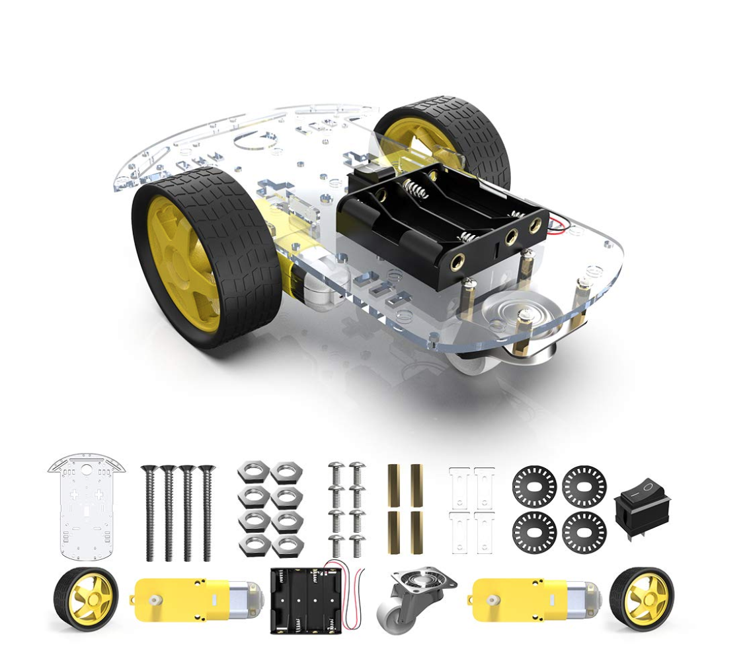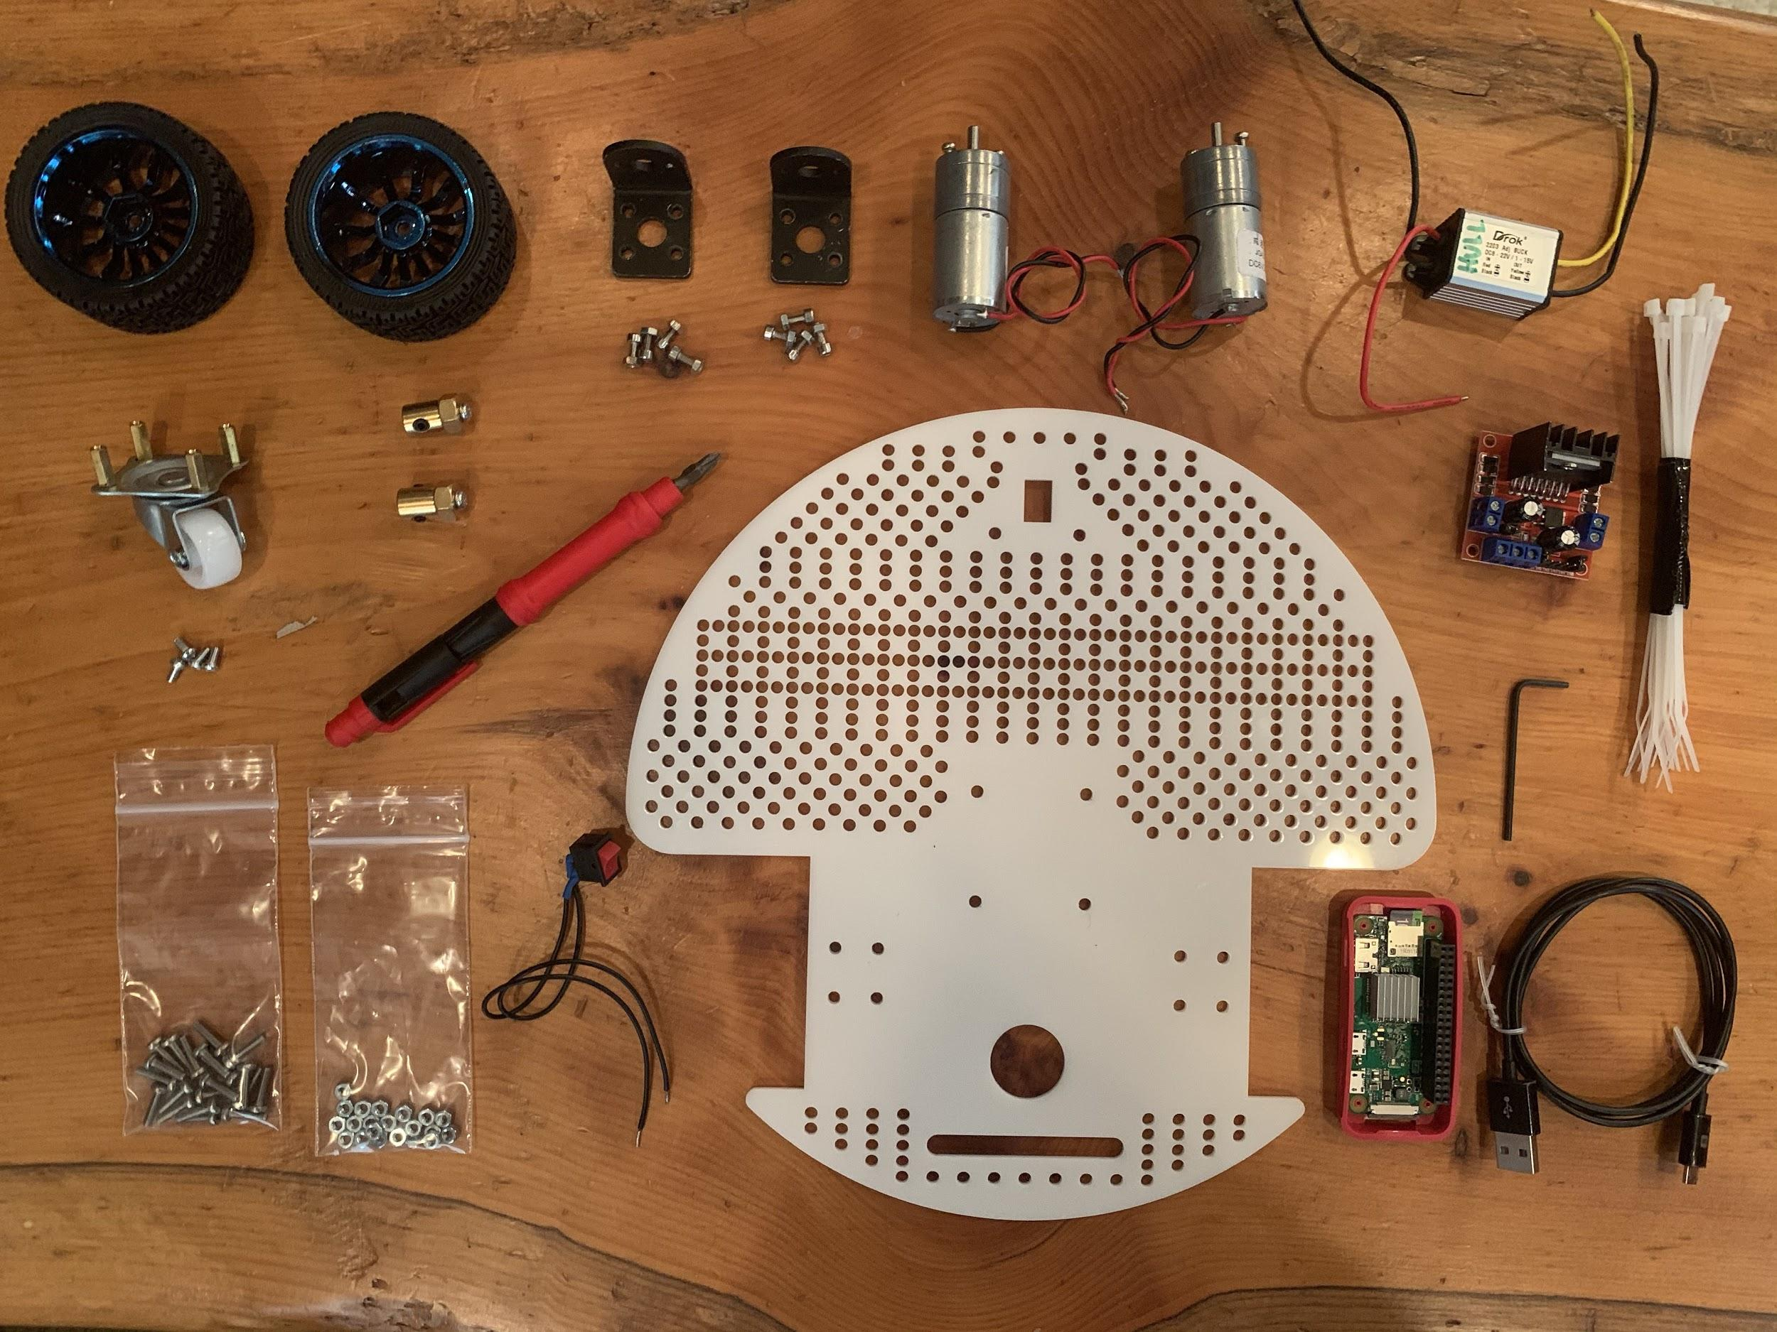

First unpack your kit and sort out all your parts. You’ll also need:

* A screwdriver
* Soldering Iron
* Wire strippers
* Velcro
* Zip ties
* Spare wire

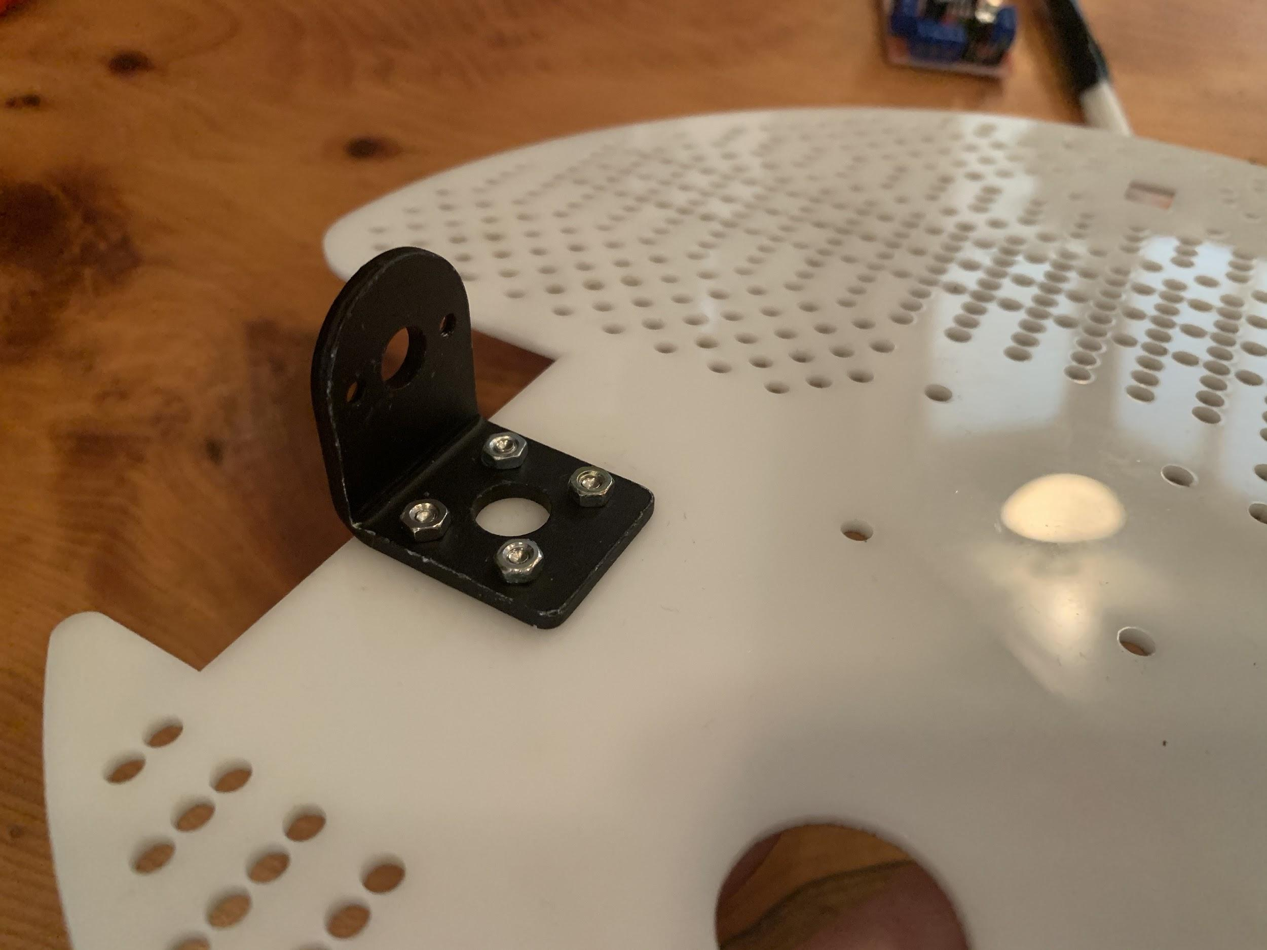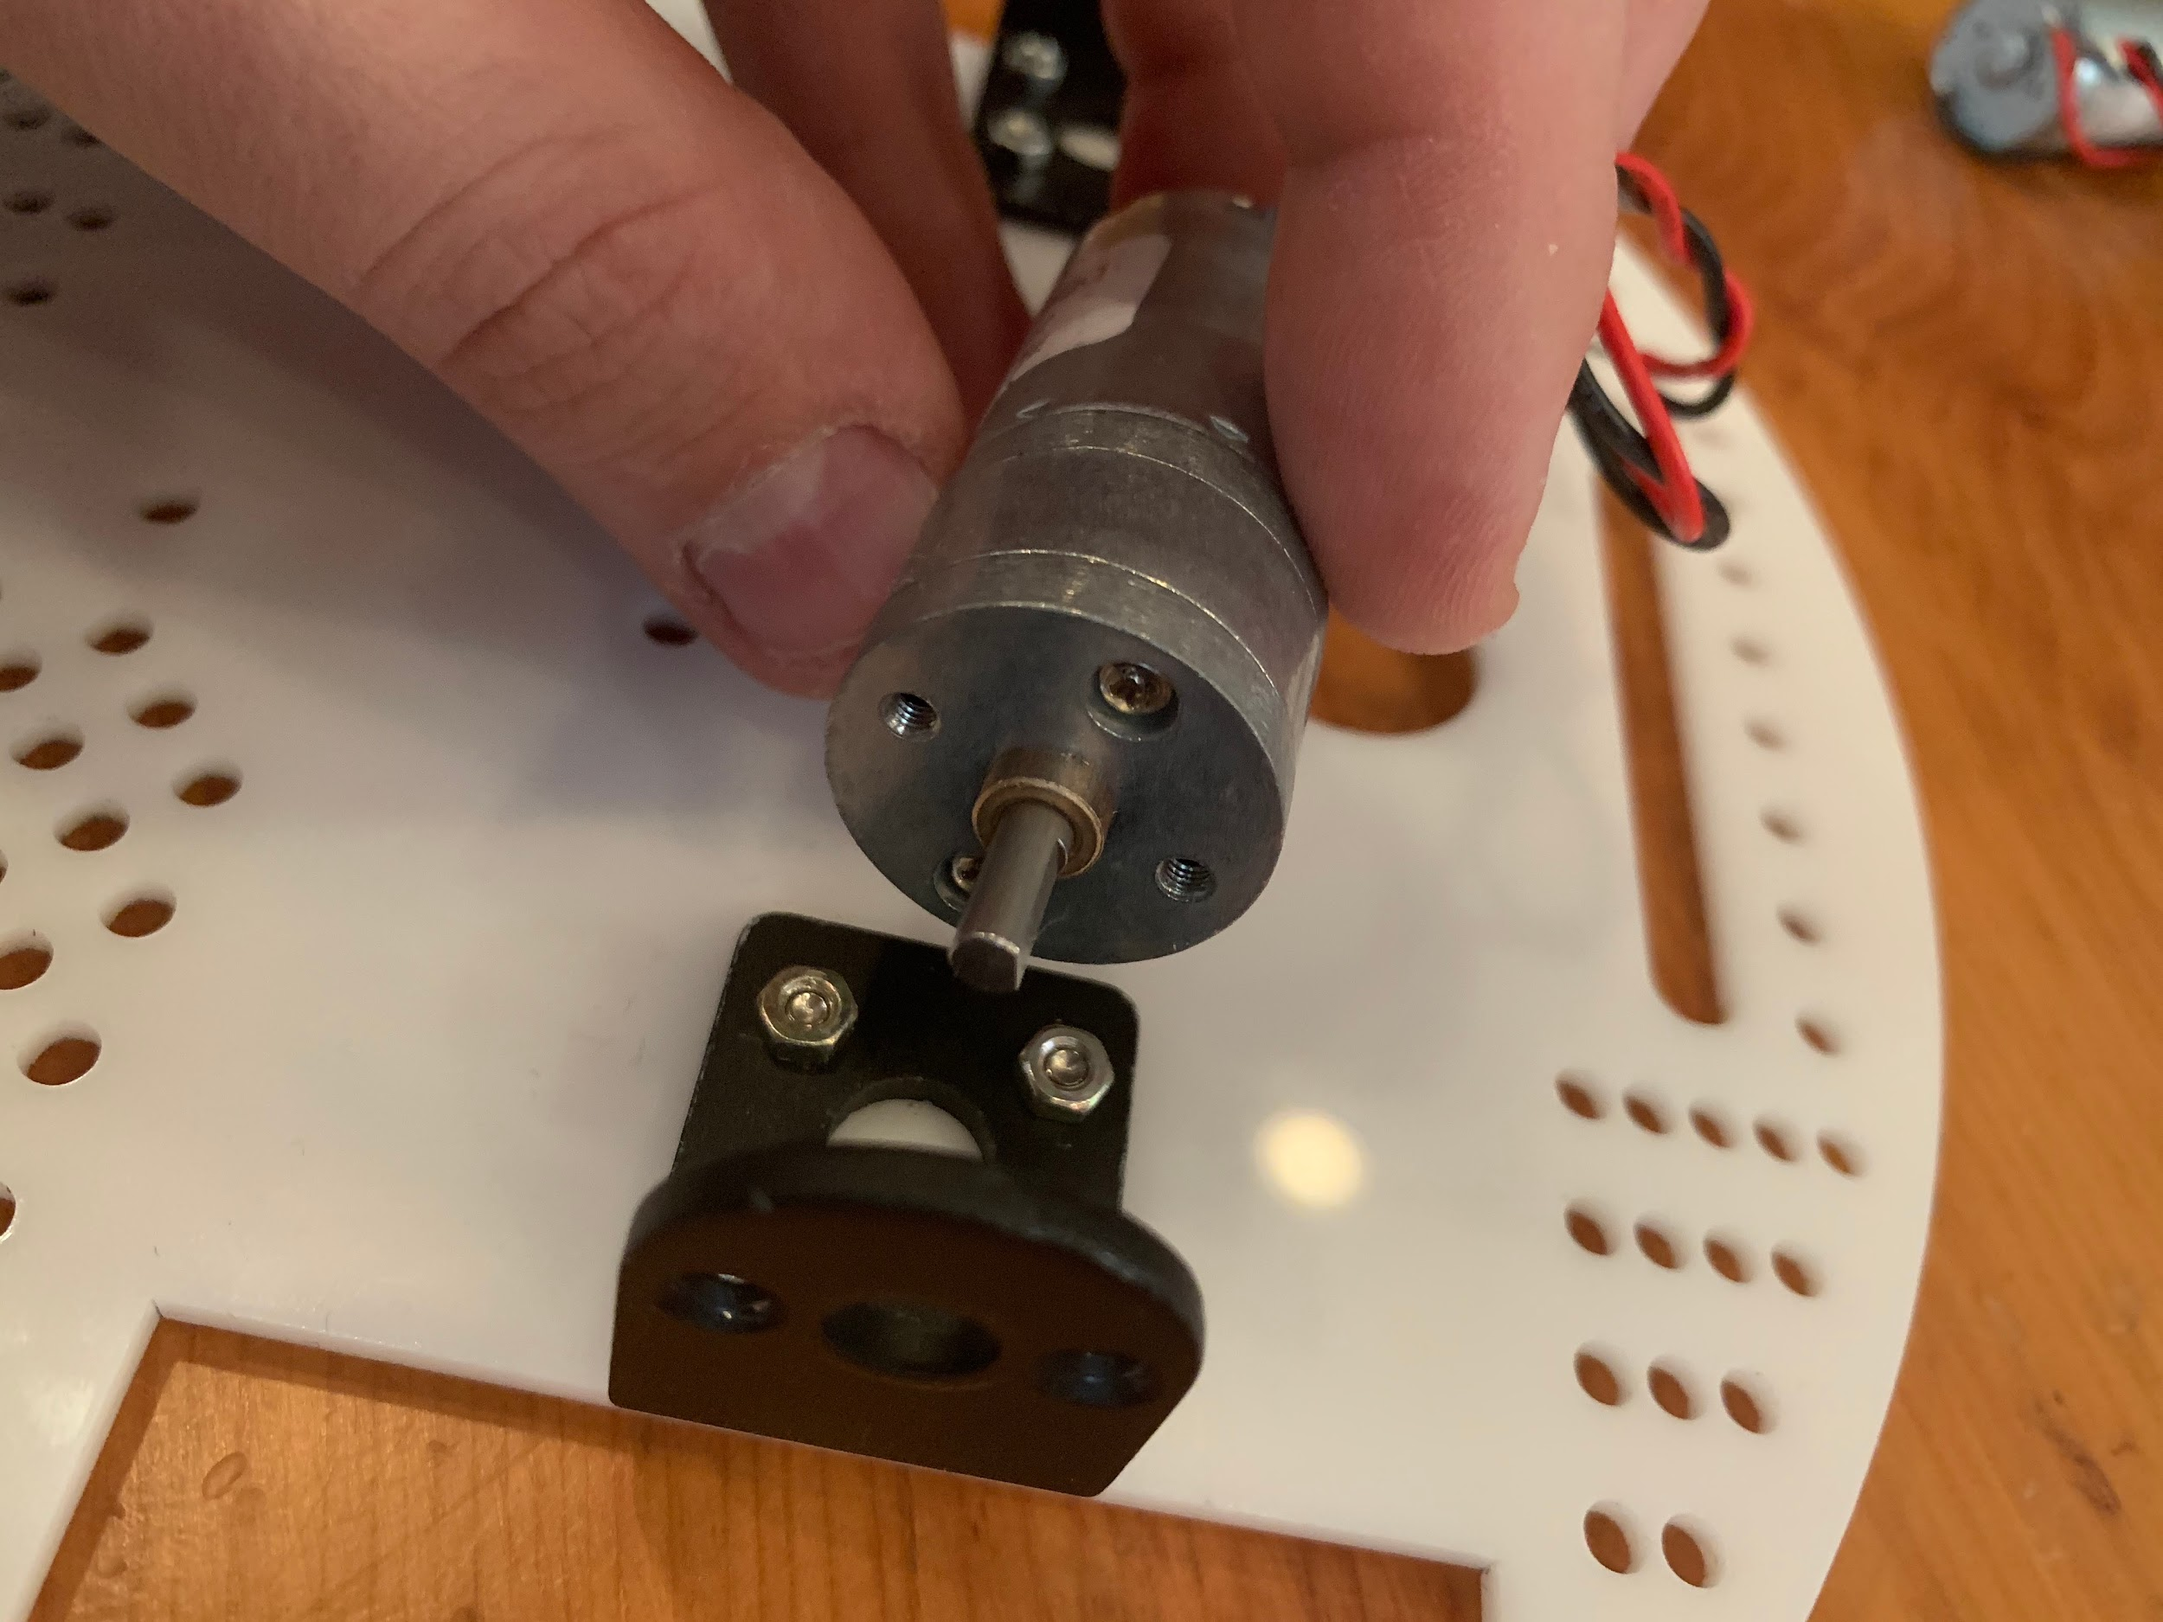

Mount the motor brackets to your base plate. Make sure you use short bolts so they don’t interfere with mounting the motor. Then mount the motor with the shaft through the center of the bracket and align the holes for mounting the motor.

If you are using the small yellow motors from your kit and you laser cut a new base, you should keep the mounting parts that were cut from the base. Then slot the mounting pieces through the base plate, place your yellow motor in between them, and secure them with a bolt all the way through the motor.

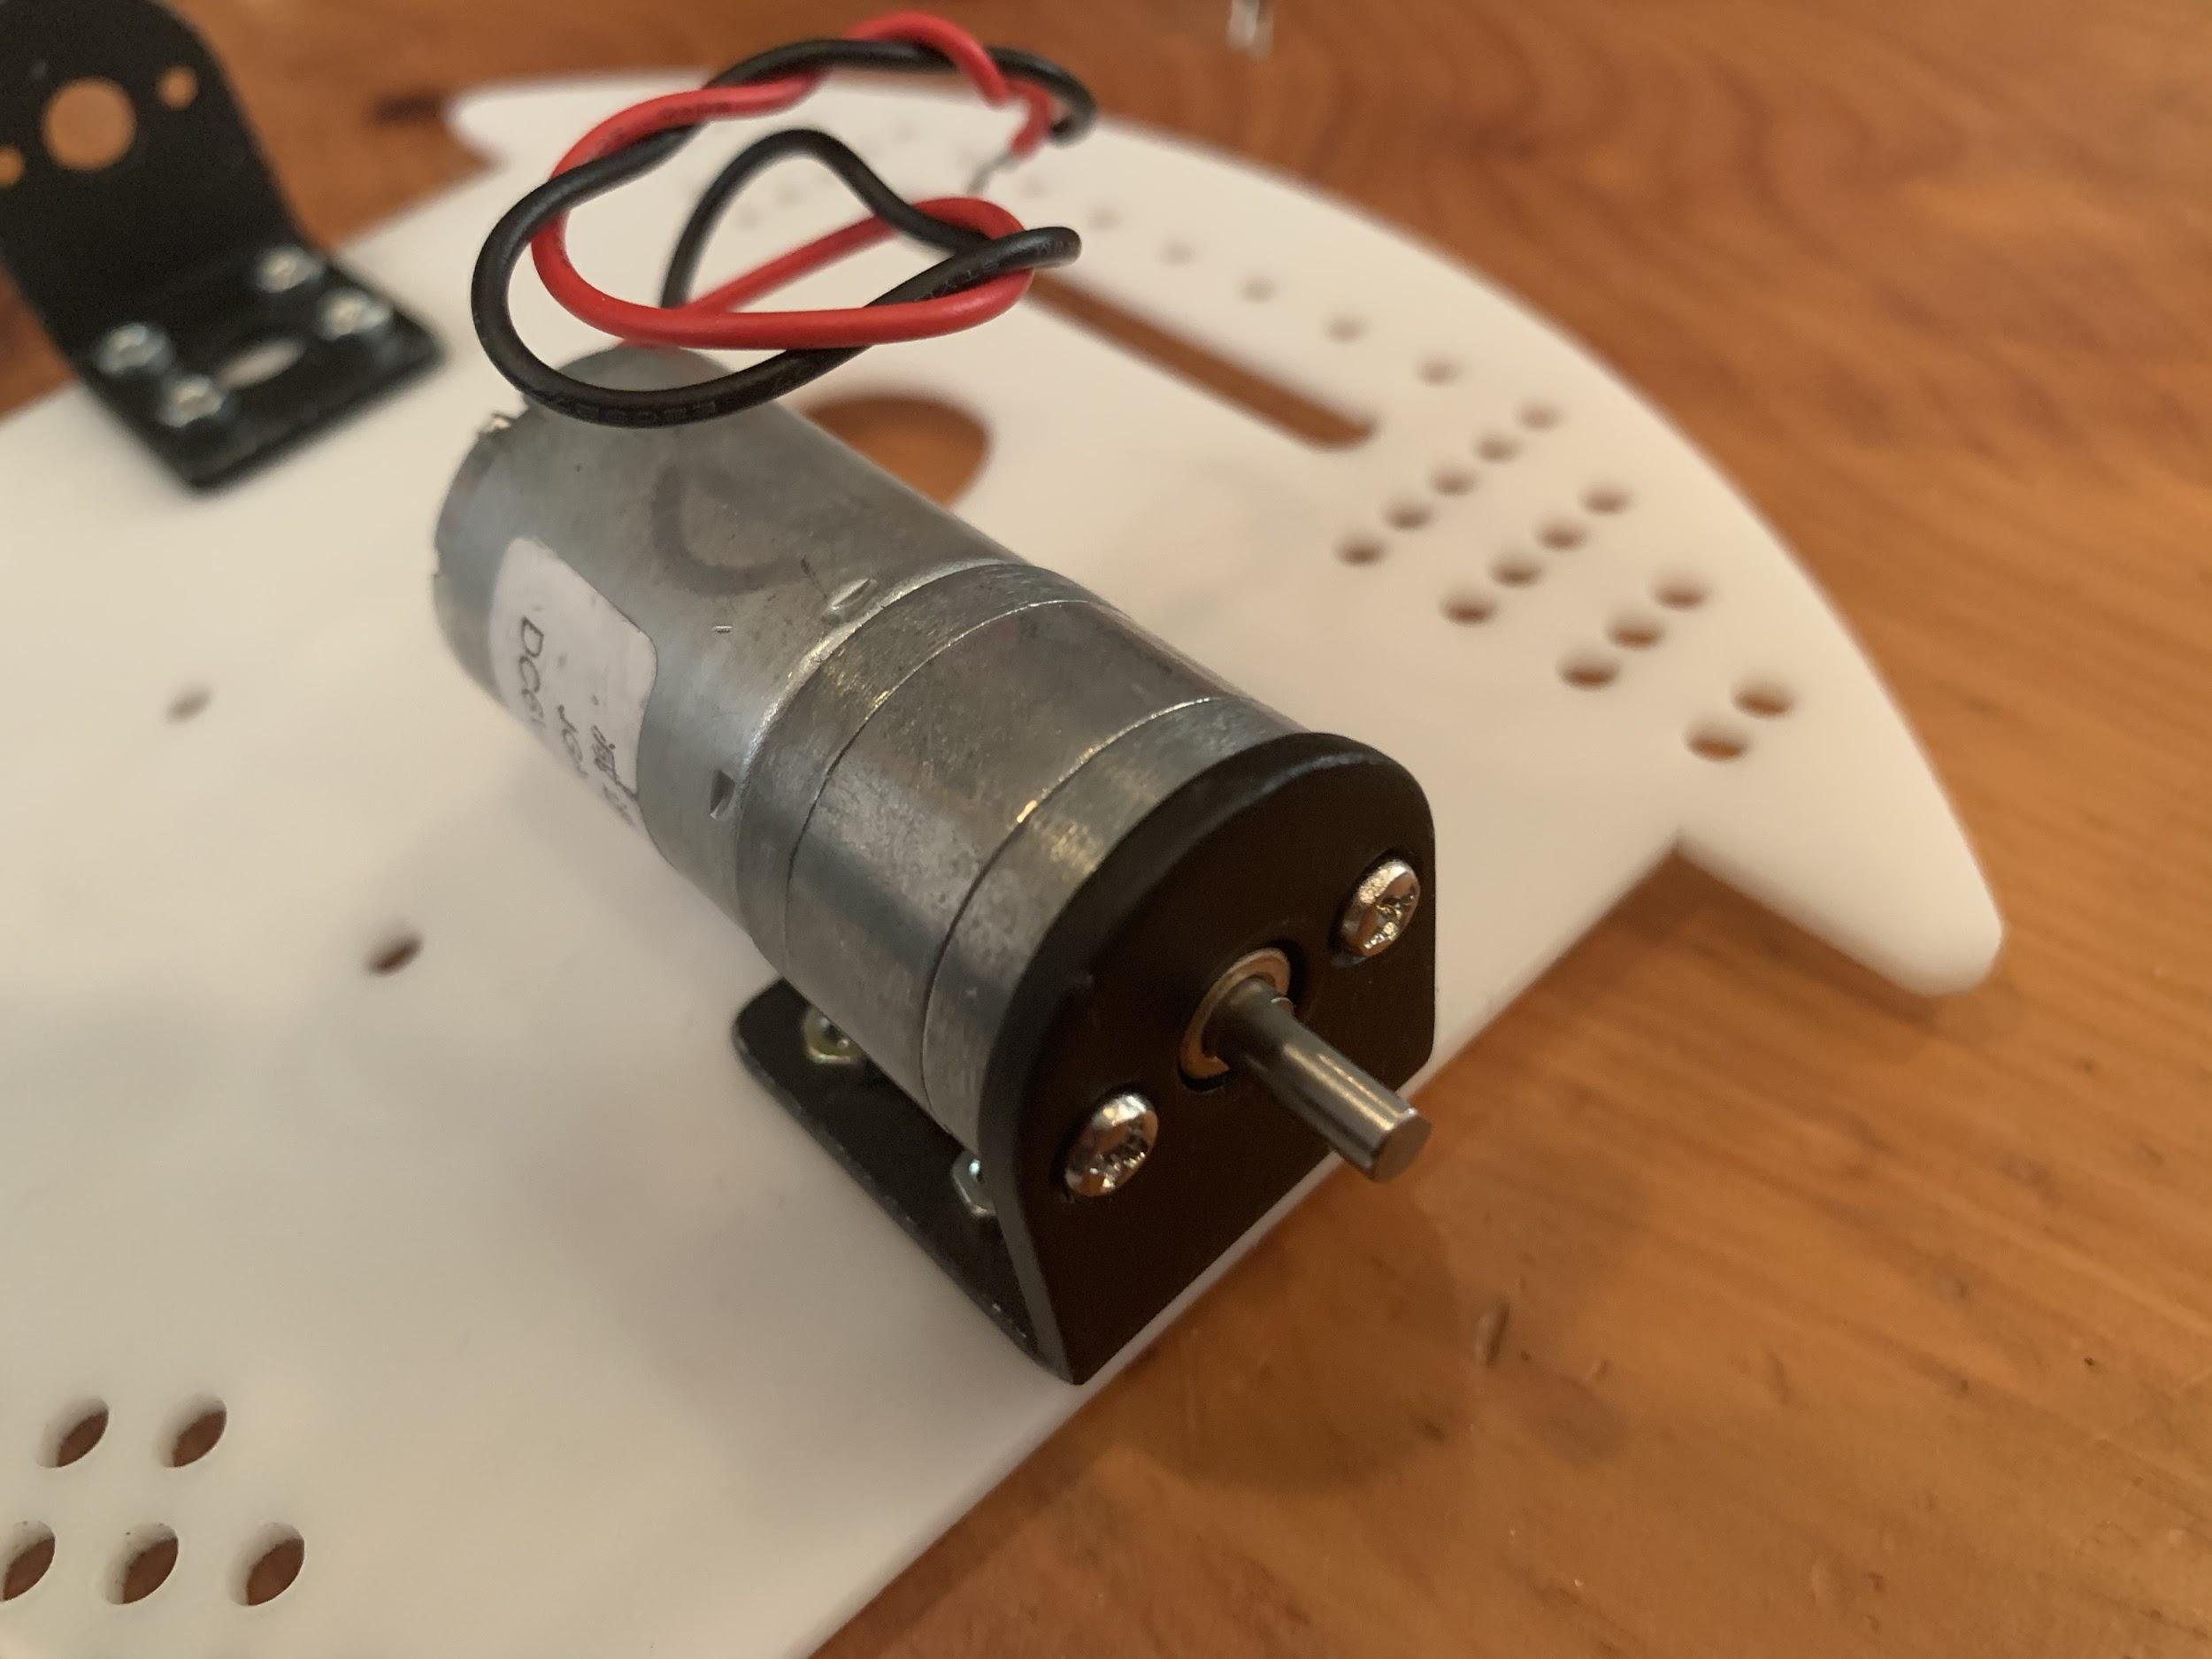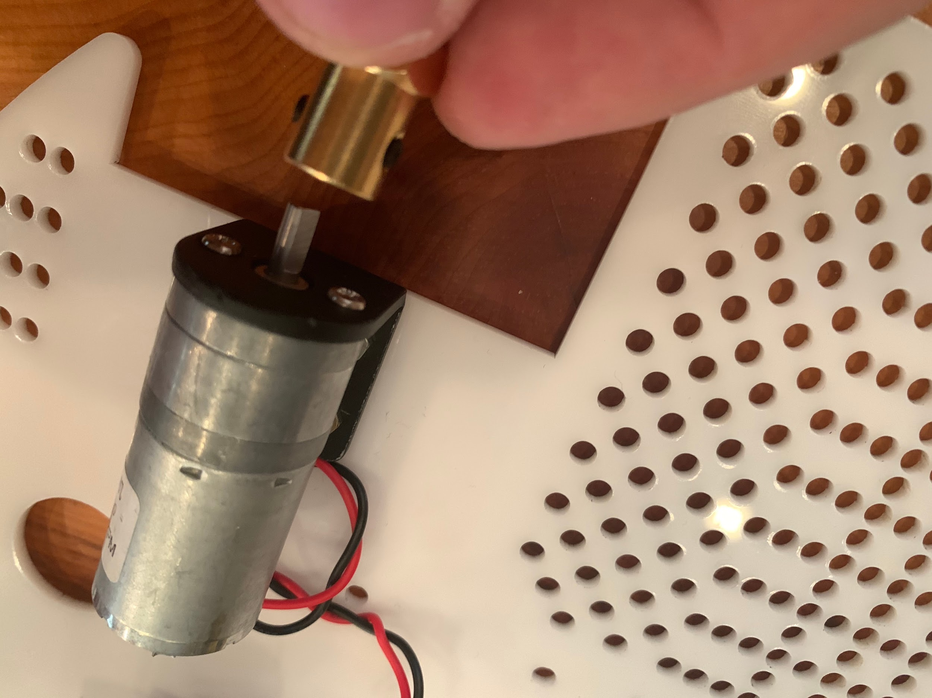

Next use your screwdriver to attach the screws to the motor placing them through the mounting bracket. Use a hex wrench to loosen the set screws in the brass collet for the wheels.Then slide the collet onto the motor shaft and allight one of the set screws to the flat side of the motor shaft. Tighten the set screws onto the motor shaft, taking care to make sure the collet doesn’t run against the motor.

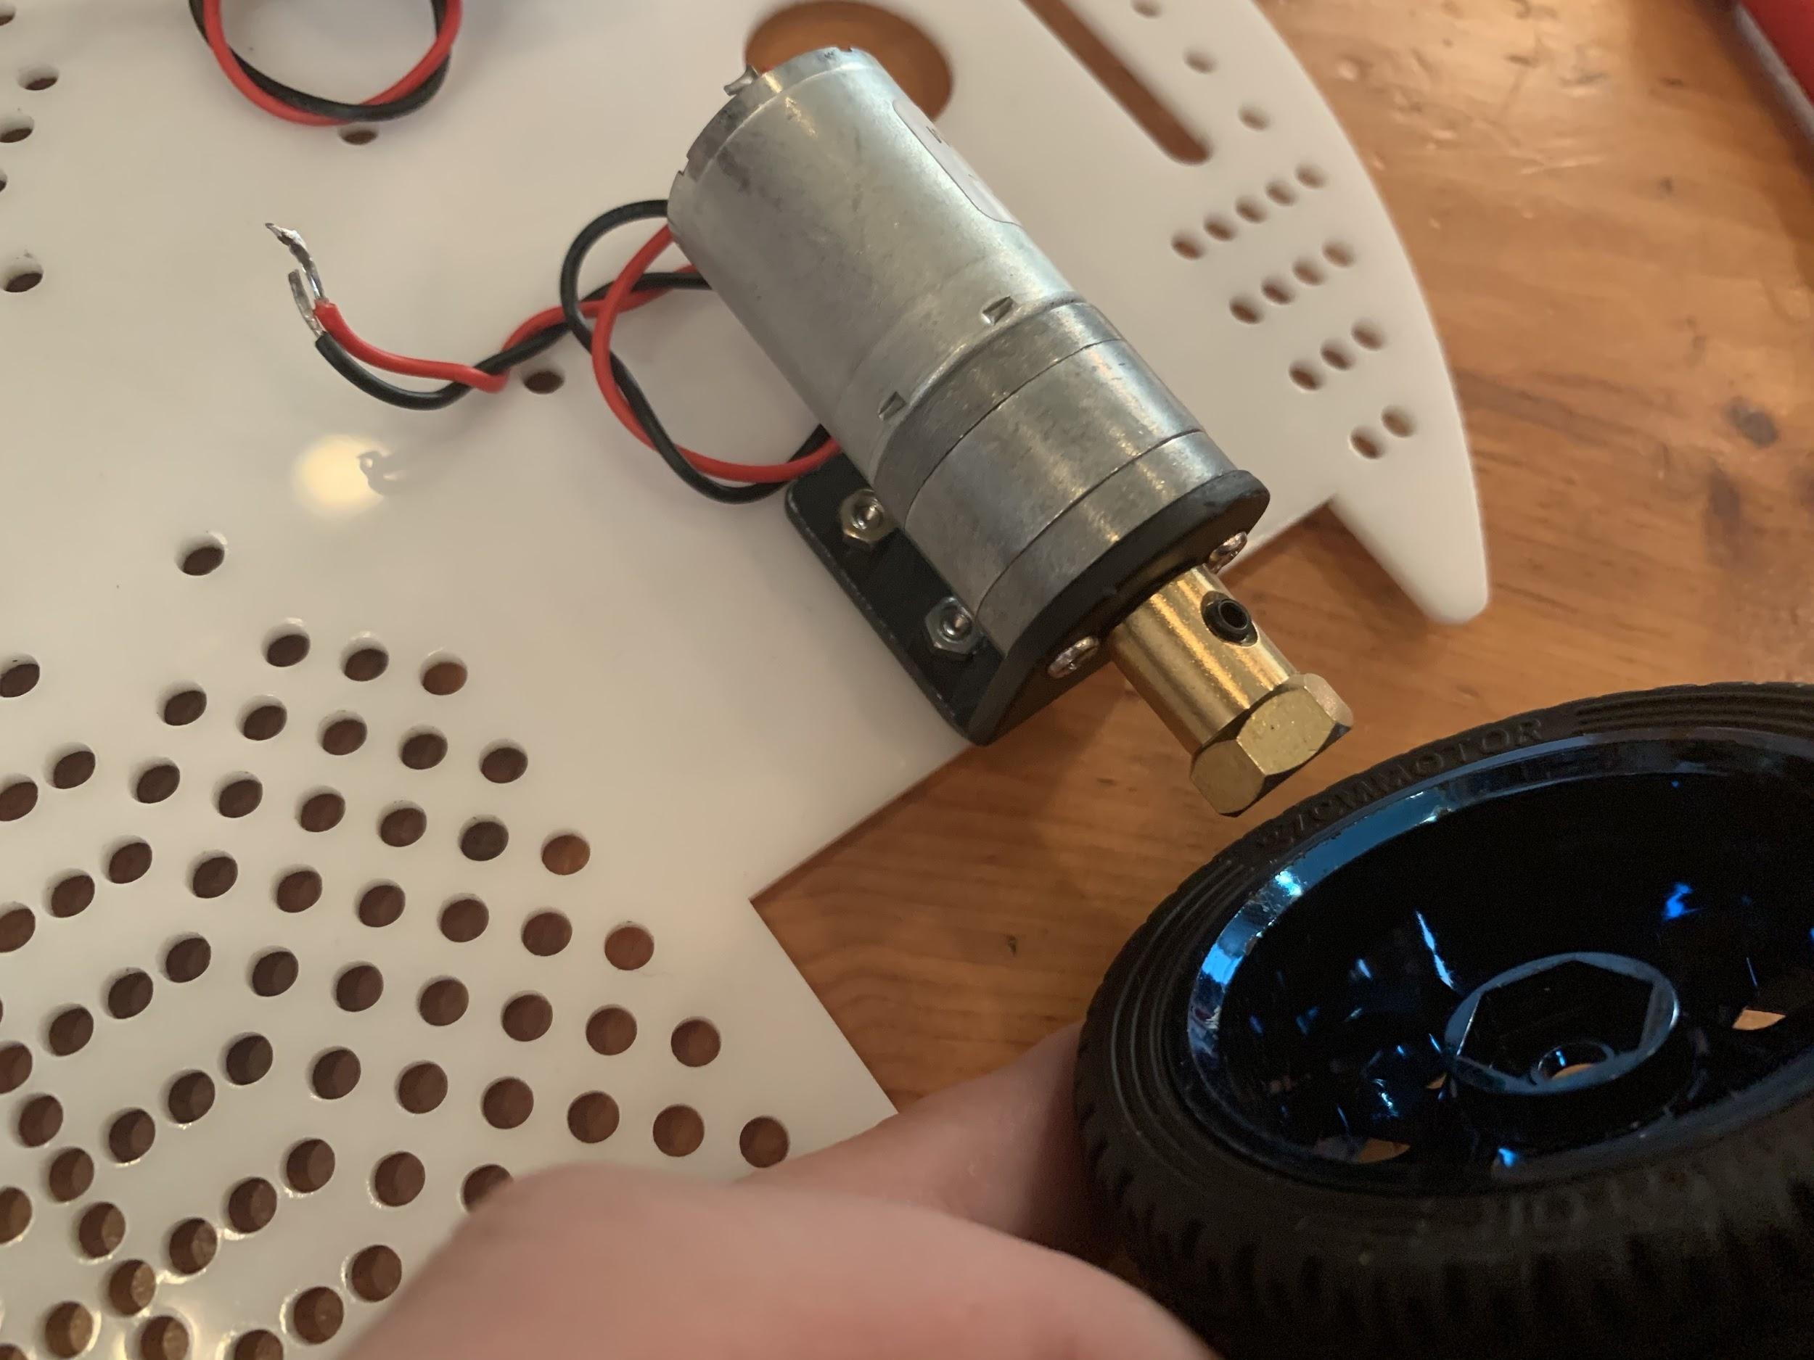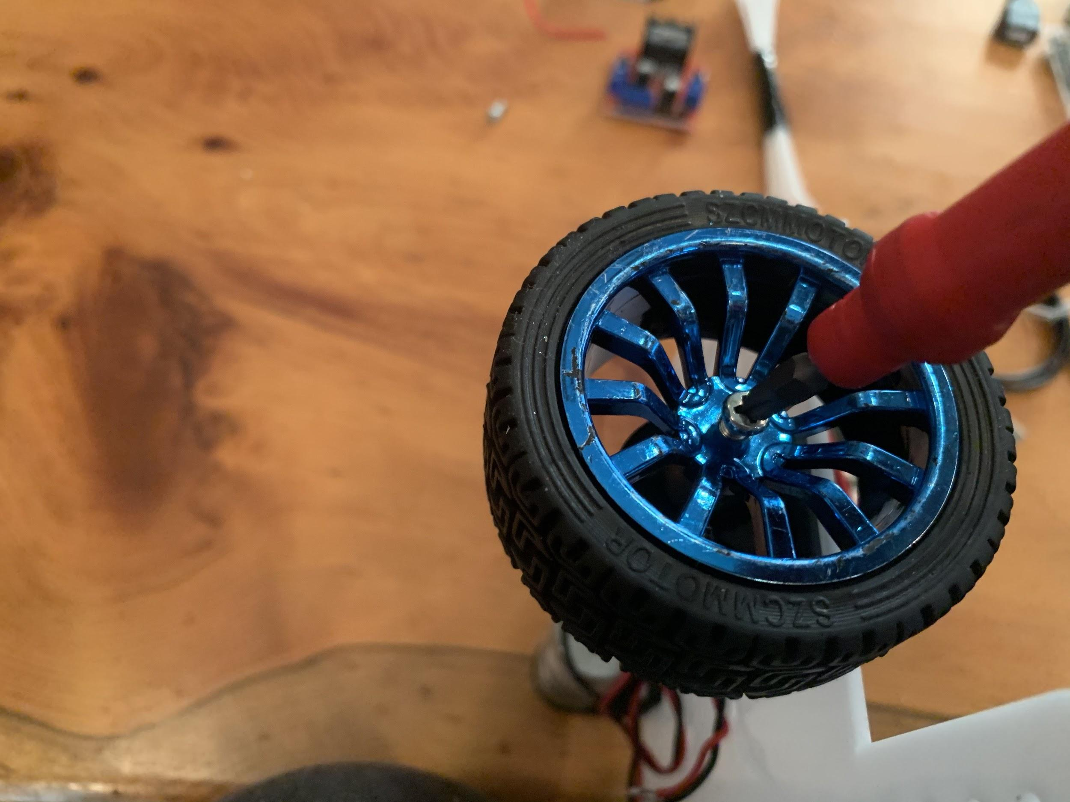

Place the wheel onto the collet hex head. Then attach the wheel screw to secure the wheel to the motor.

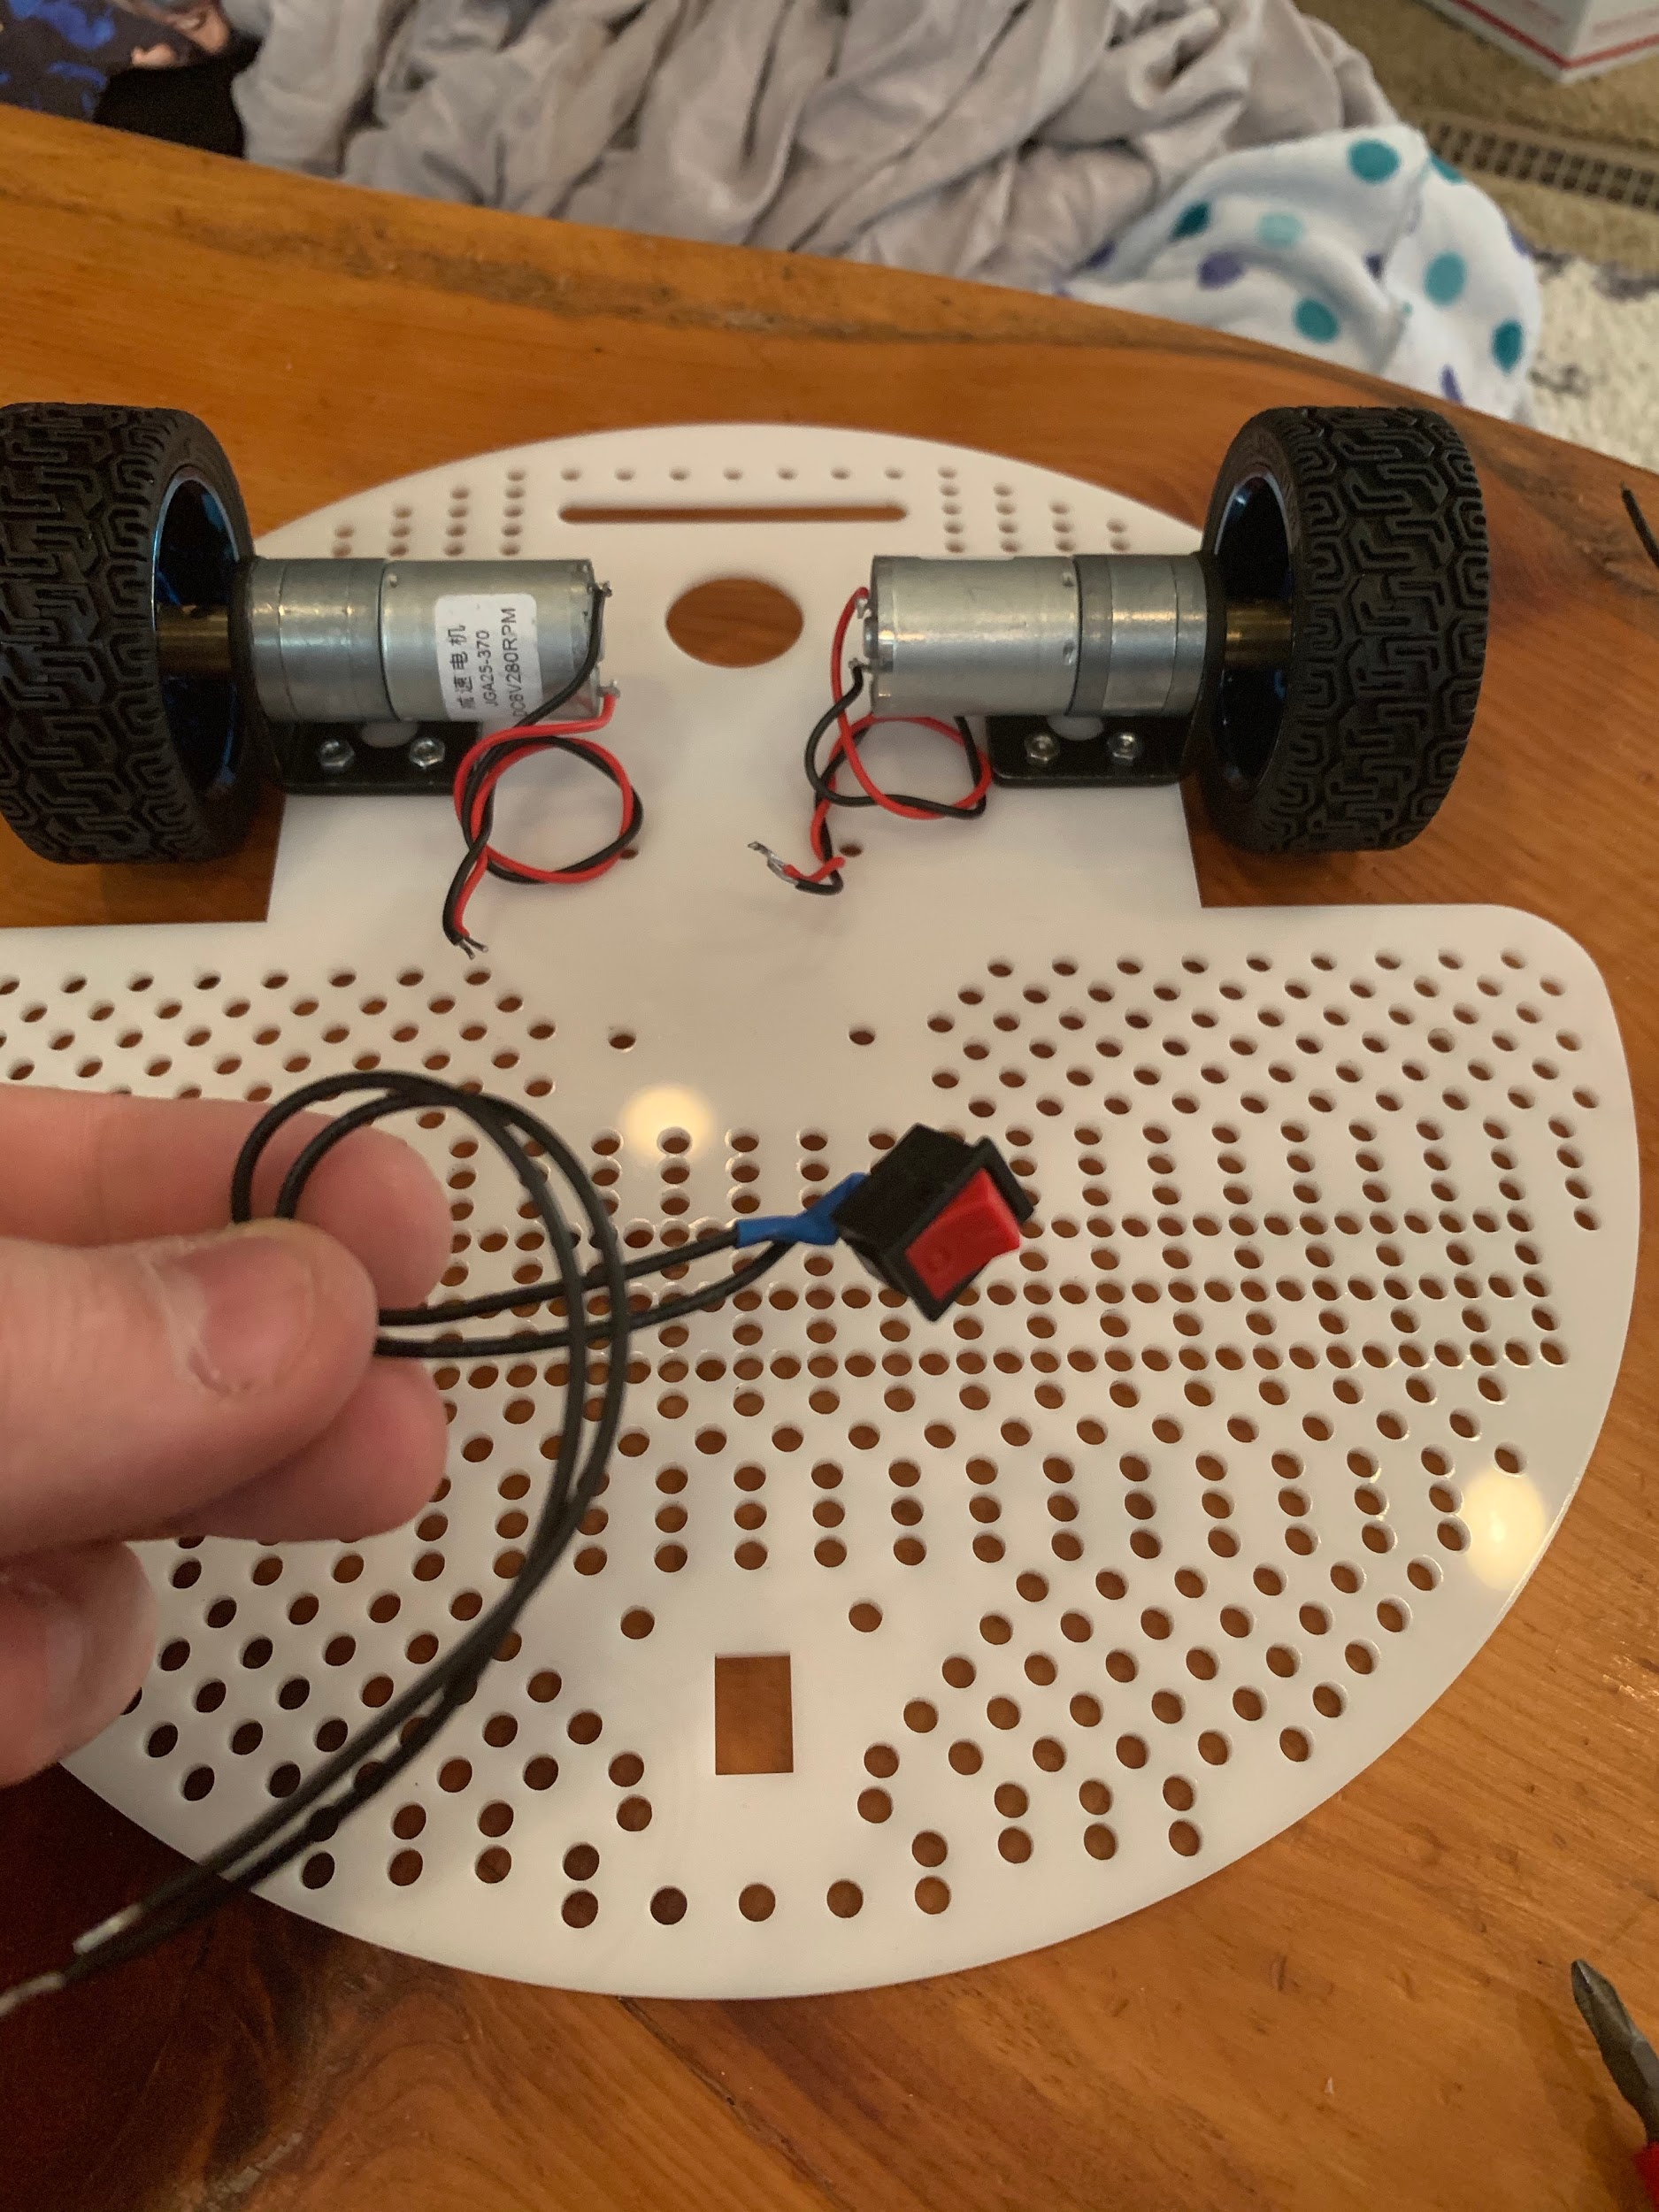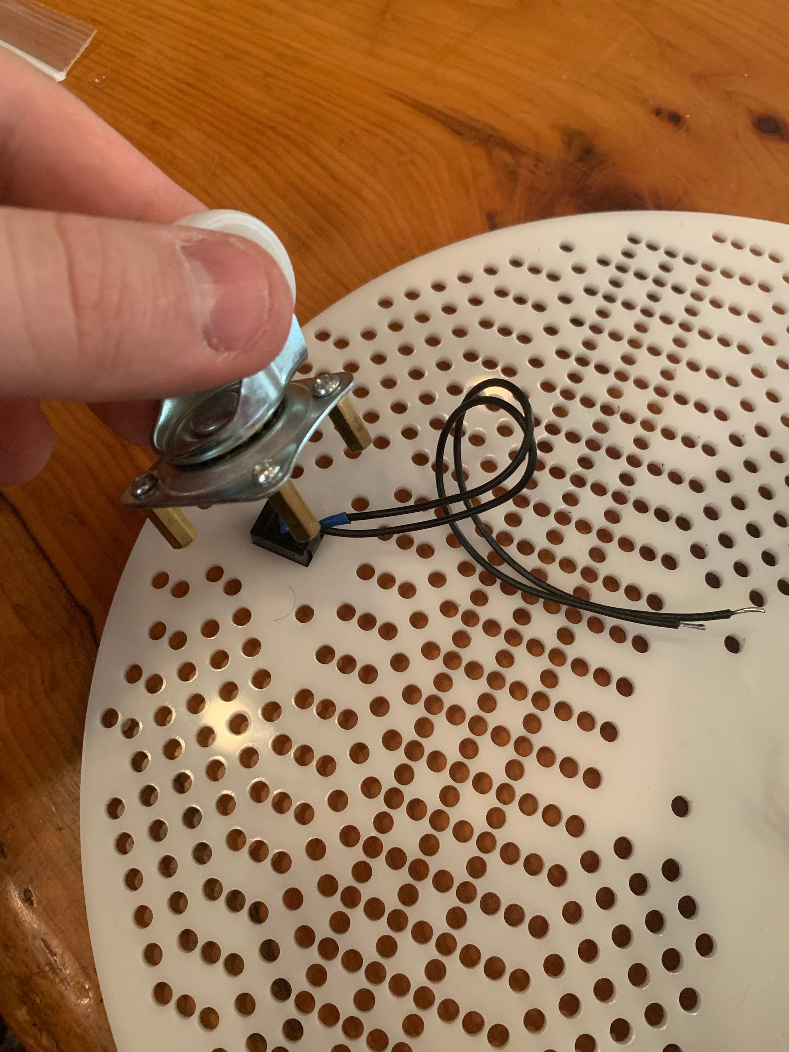

Solder wires to your power switch and pop it into the rectangular space in the base plate. Then mount the back wheel over the top of the switch.

**Start Adding Electronics**

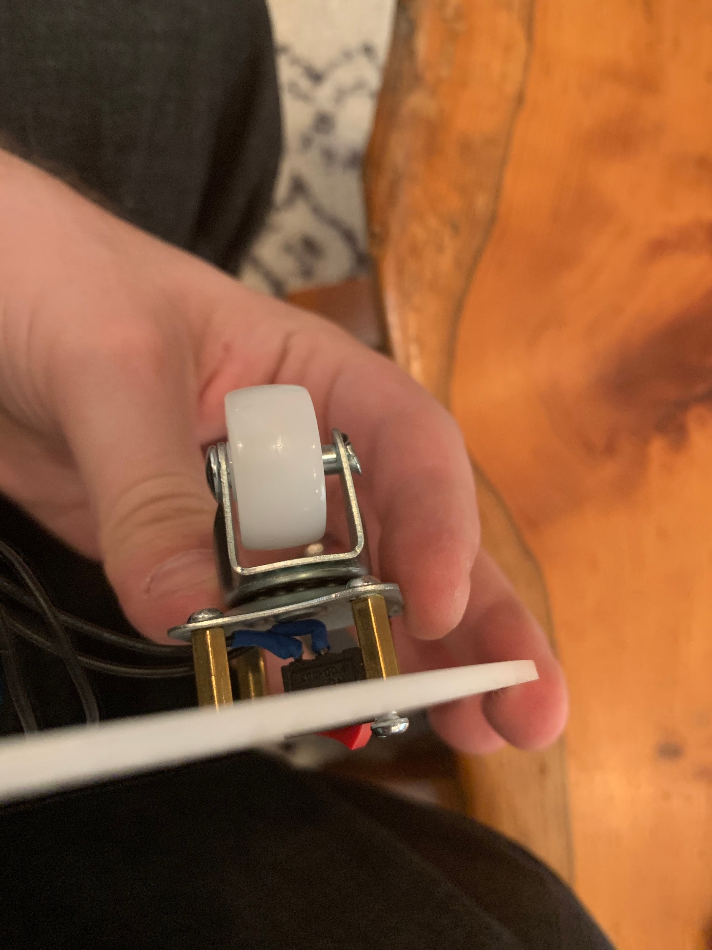 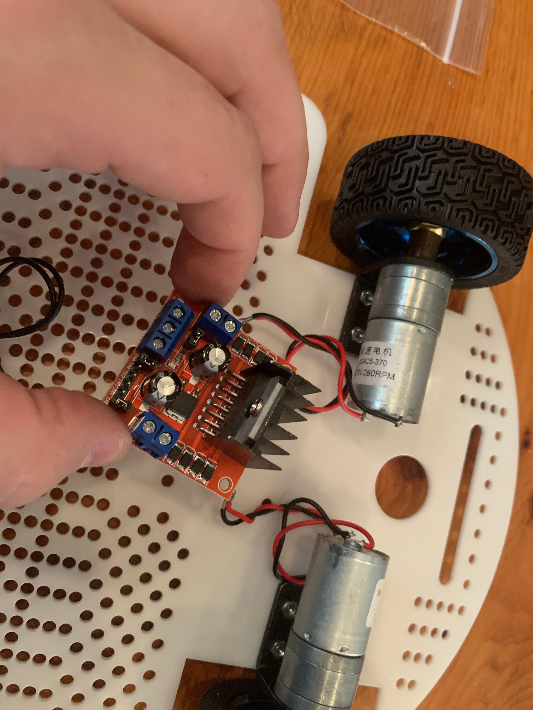

Now that our motors, wheels, and back wheel are mounted, let’s mount the motor control module. It’s hole pattern is right behind the motors, but it could easily be mounted wherever is convenient. If you have an upgraded motor driver, find a space to mount yours and make sure the wires for your motors are long enough to run to it.

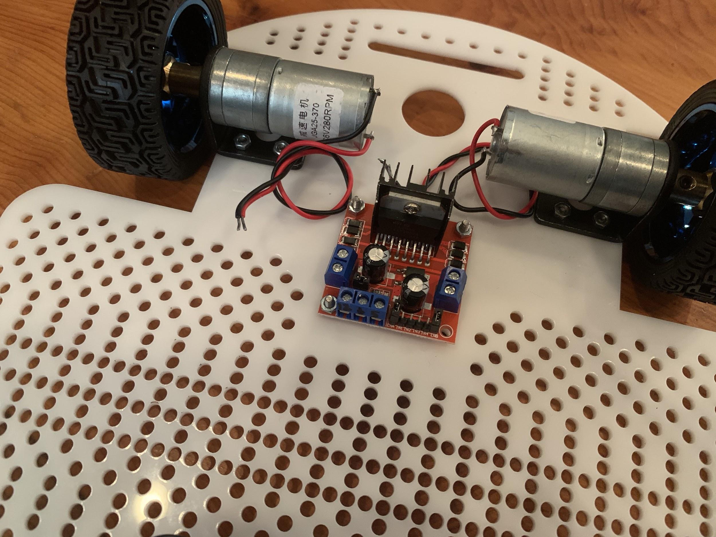

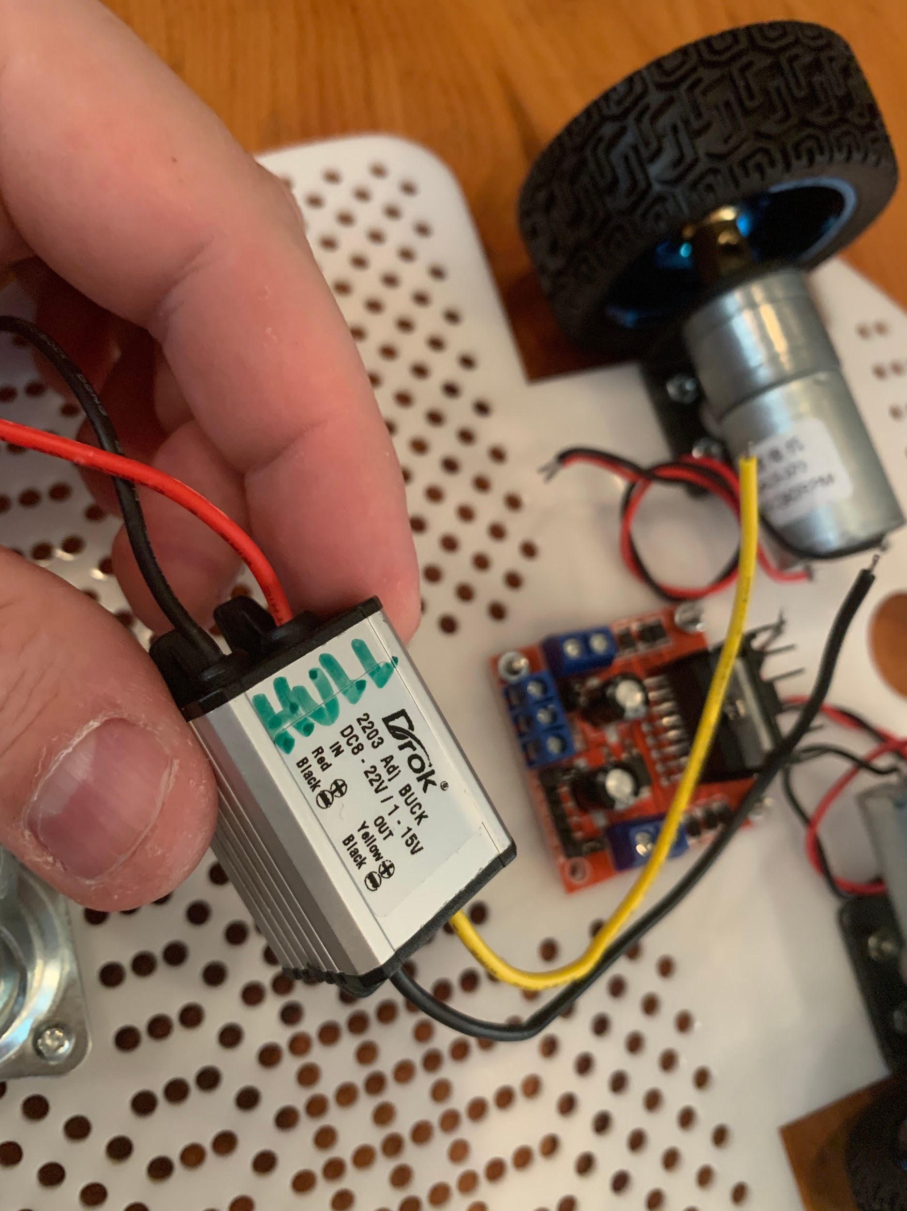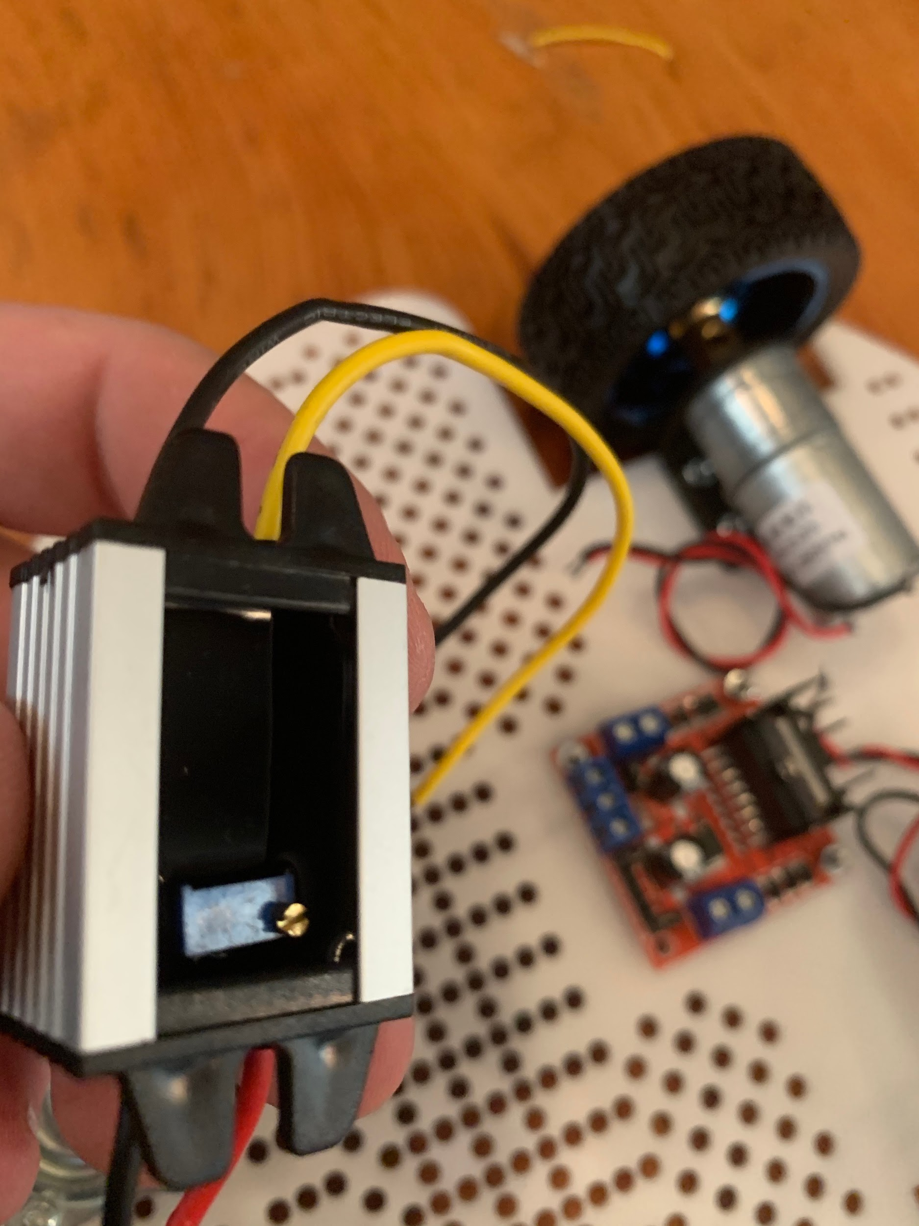

Now that our motor driver is mounted, let’s take a look at the voltage regulator. This voltage regulator is very important because the cheap motor driver can’t supply enough power to our raspberry pi. The raspberry pi needs up to 2.5 amps and the motor driver with our cheap kit can only supply 0.5 amps. This means that without the voltage regulator we’re very susceptible to brownouts and irregular outputs.

This voltage regulator can supply a large range of outputs, so we need to set the output voltage using the potentiometer on the underside.

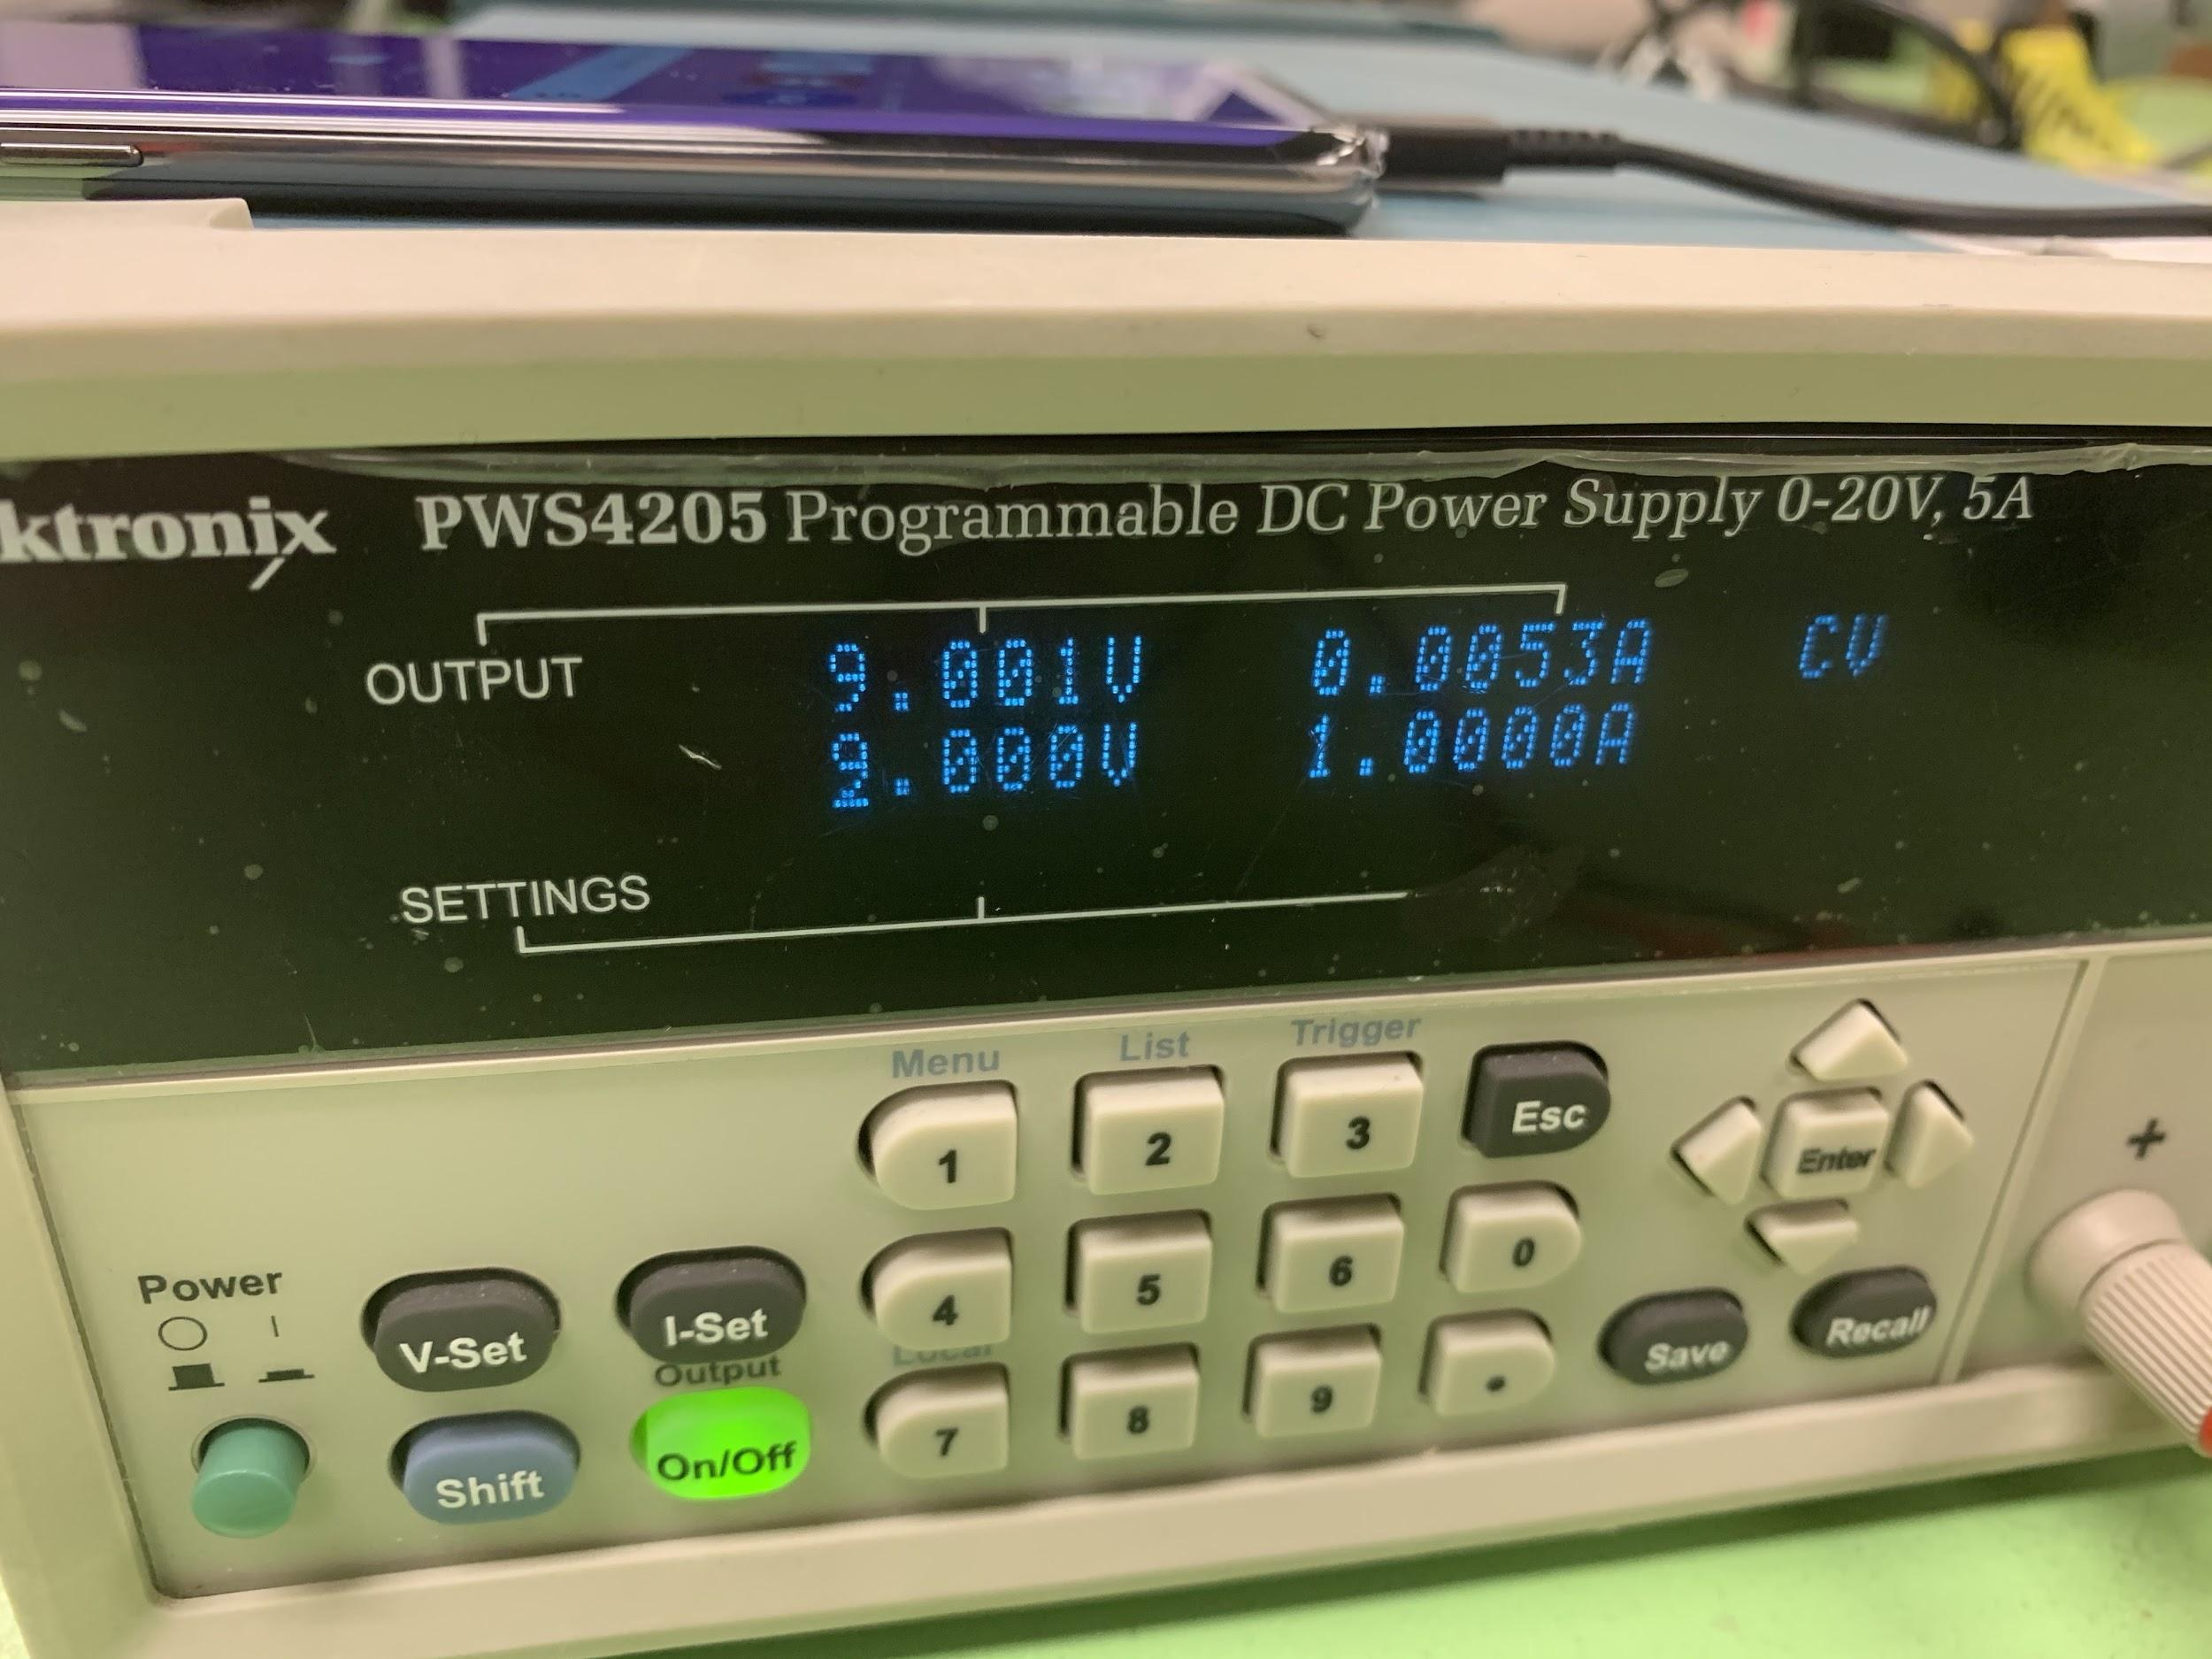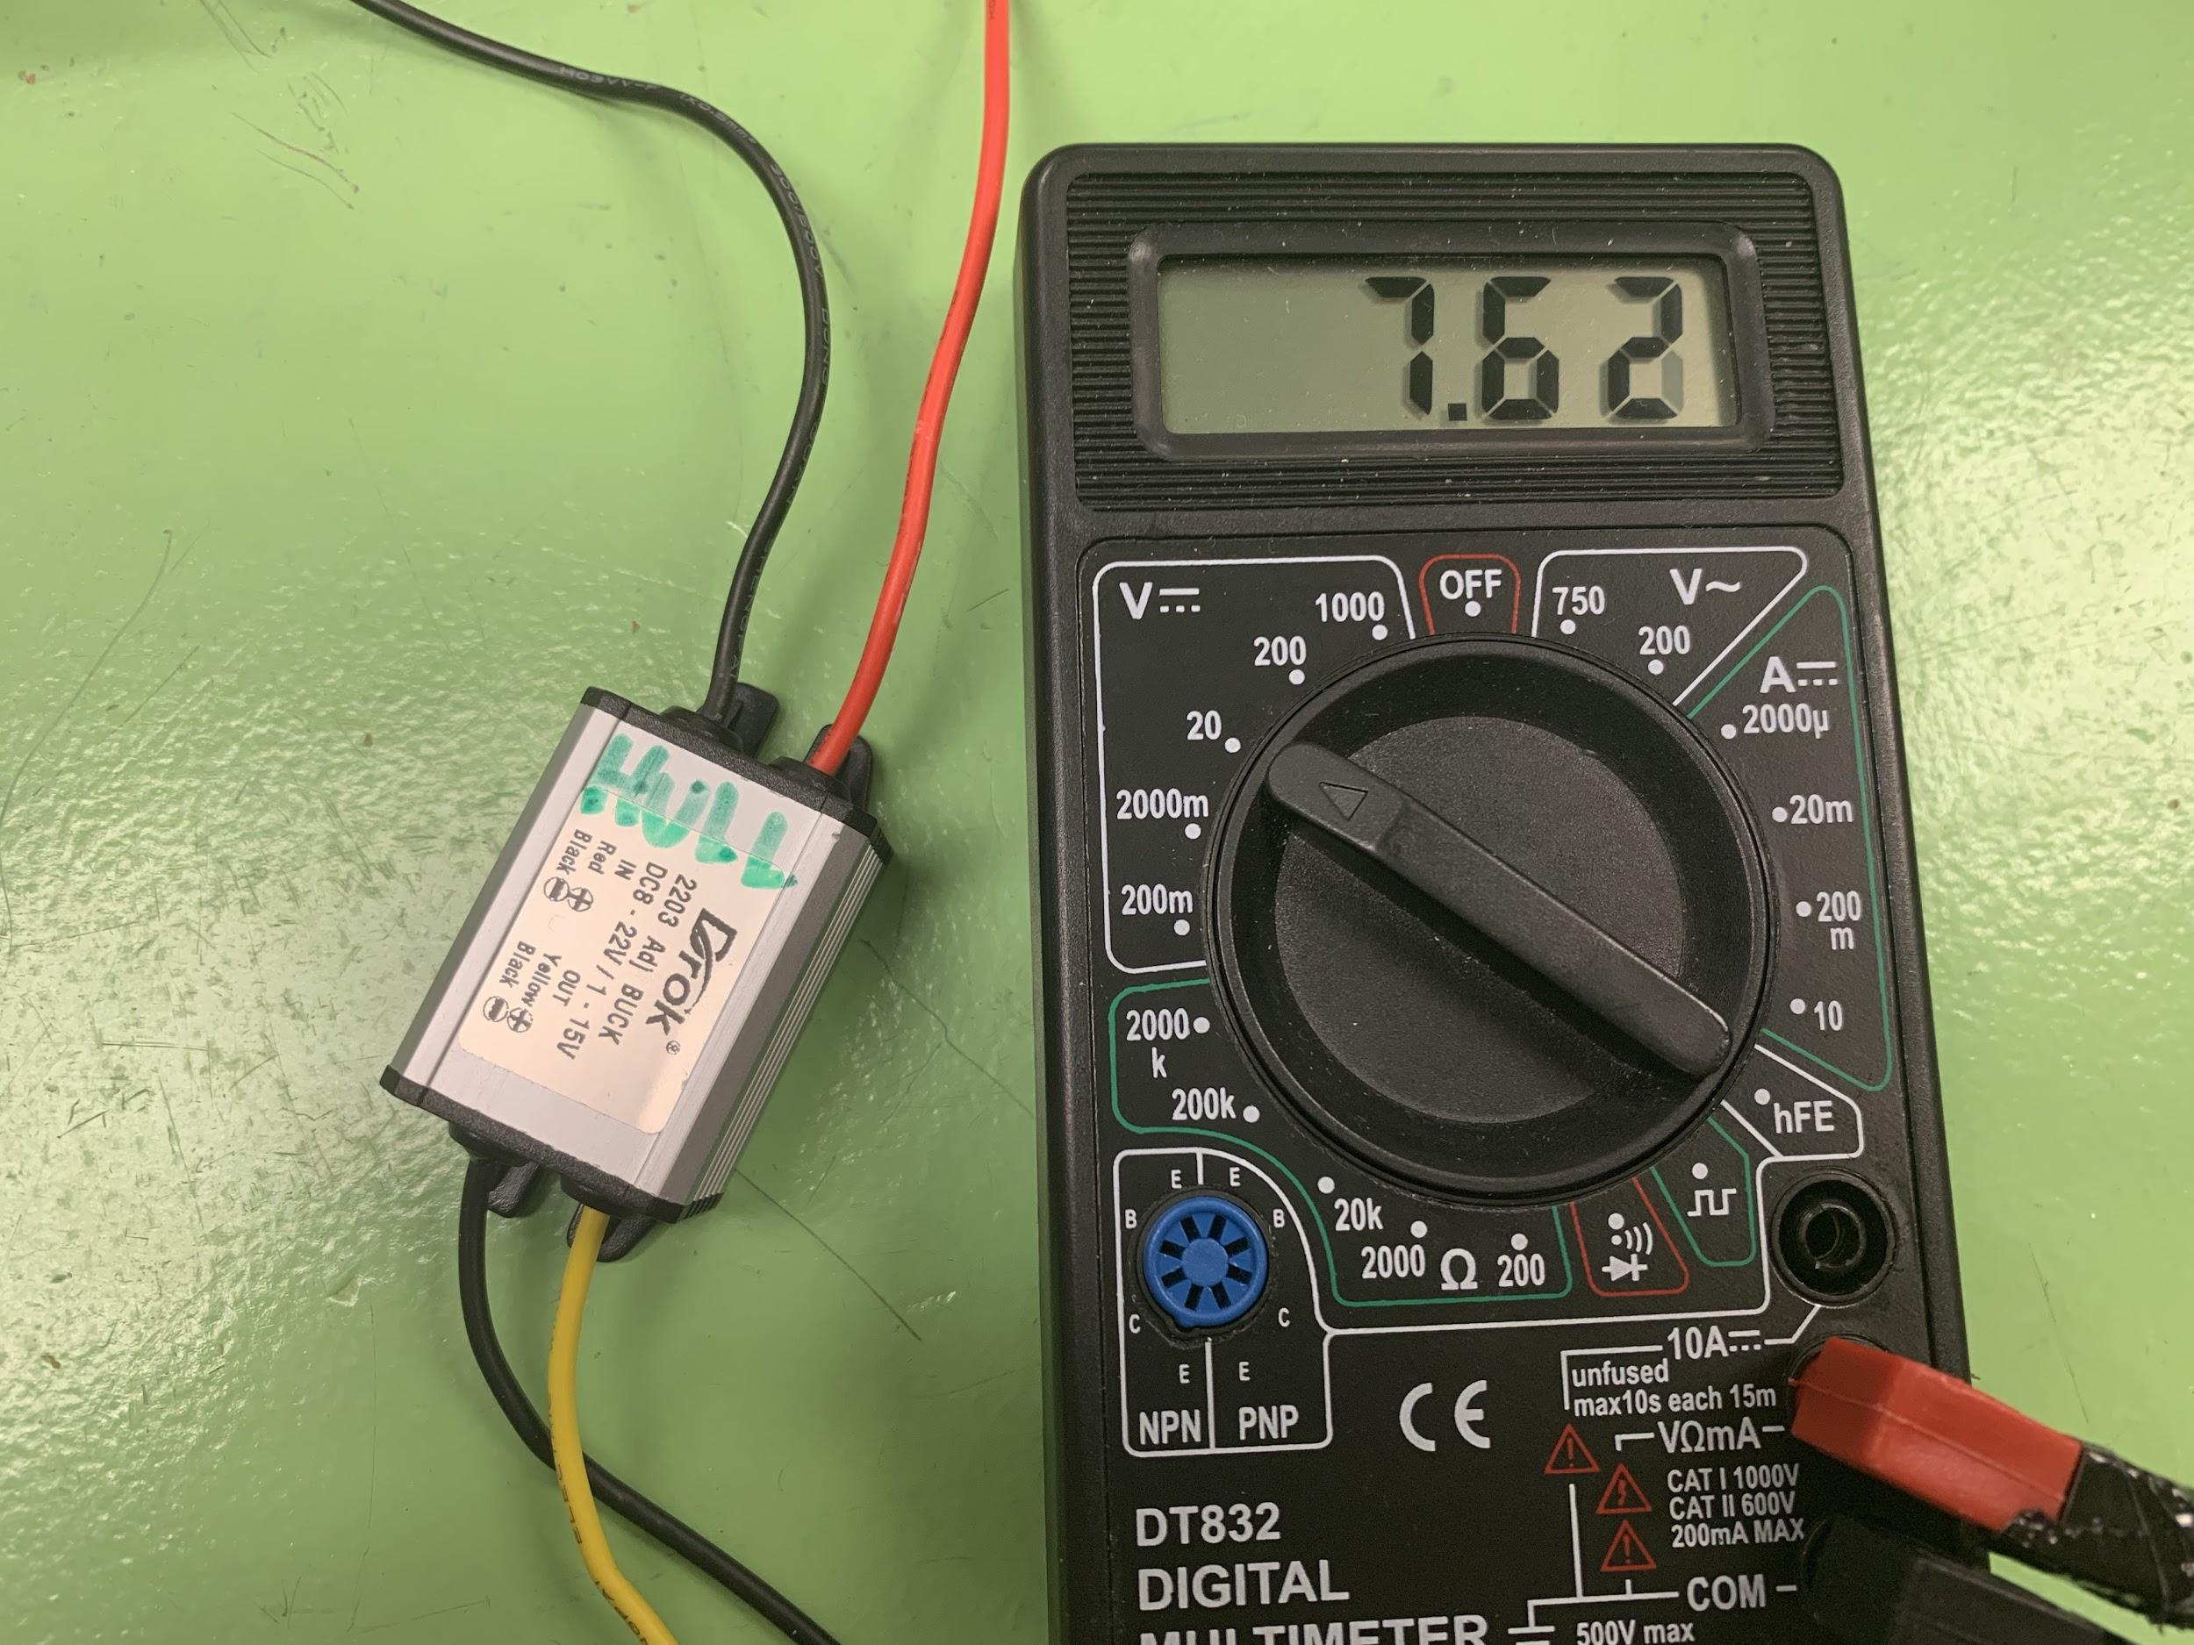

Hook up a power source to the voltage regulator input multimeter to the output. We want to make sure that we are outputting 5V so we don’t damage the Raspberry pi.

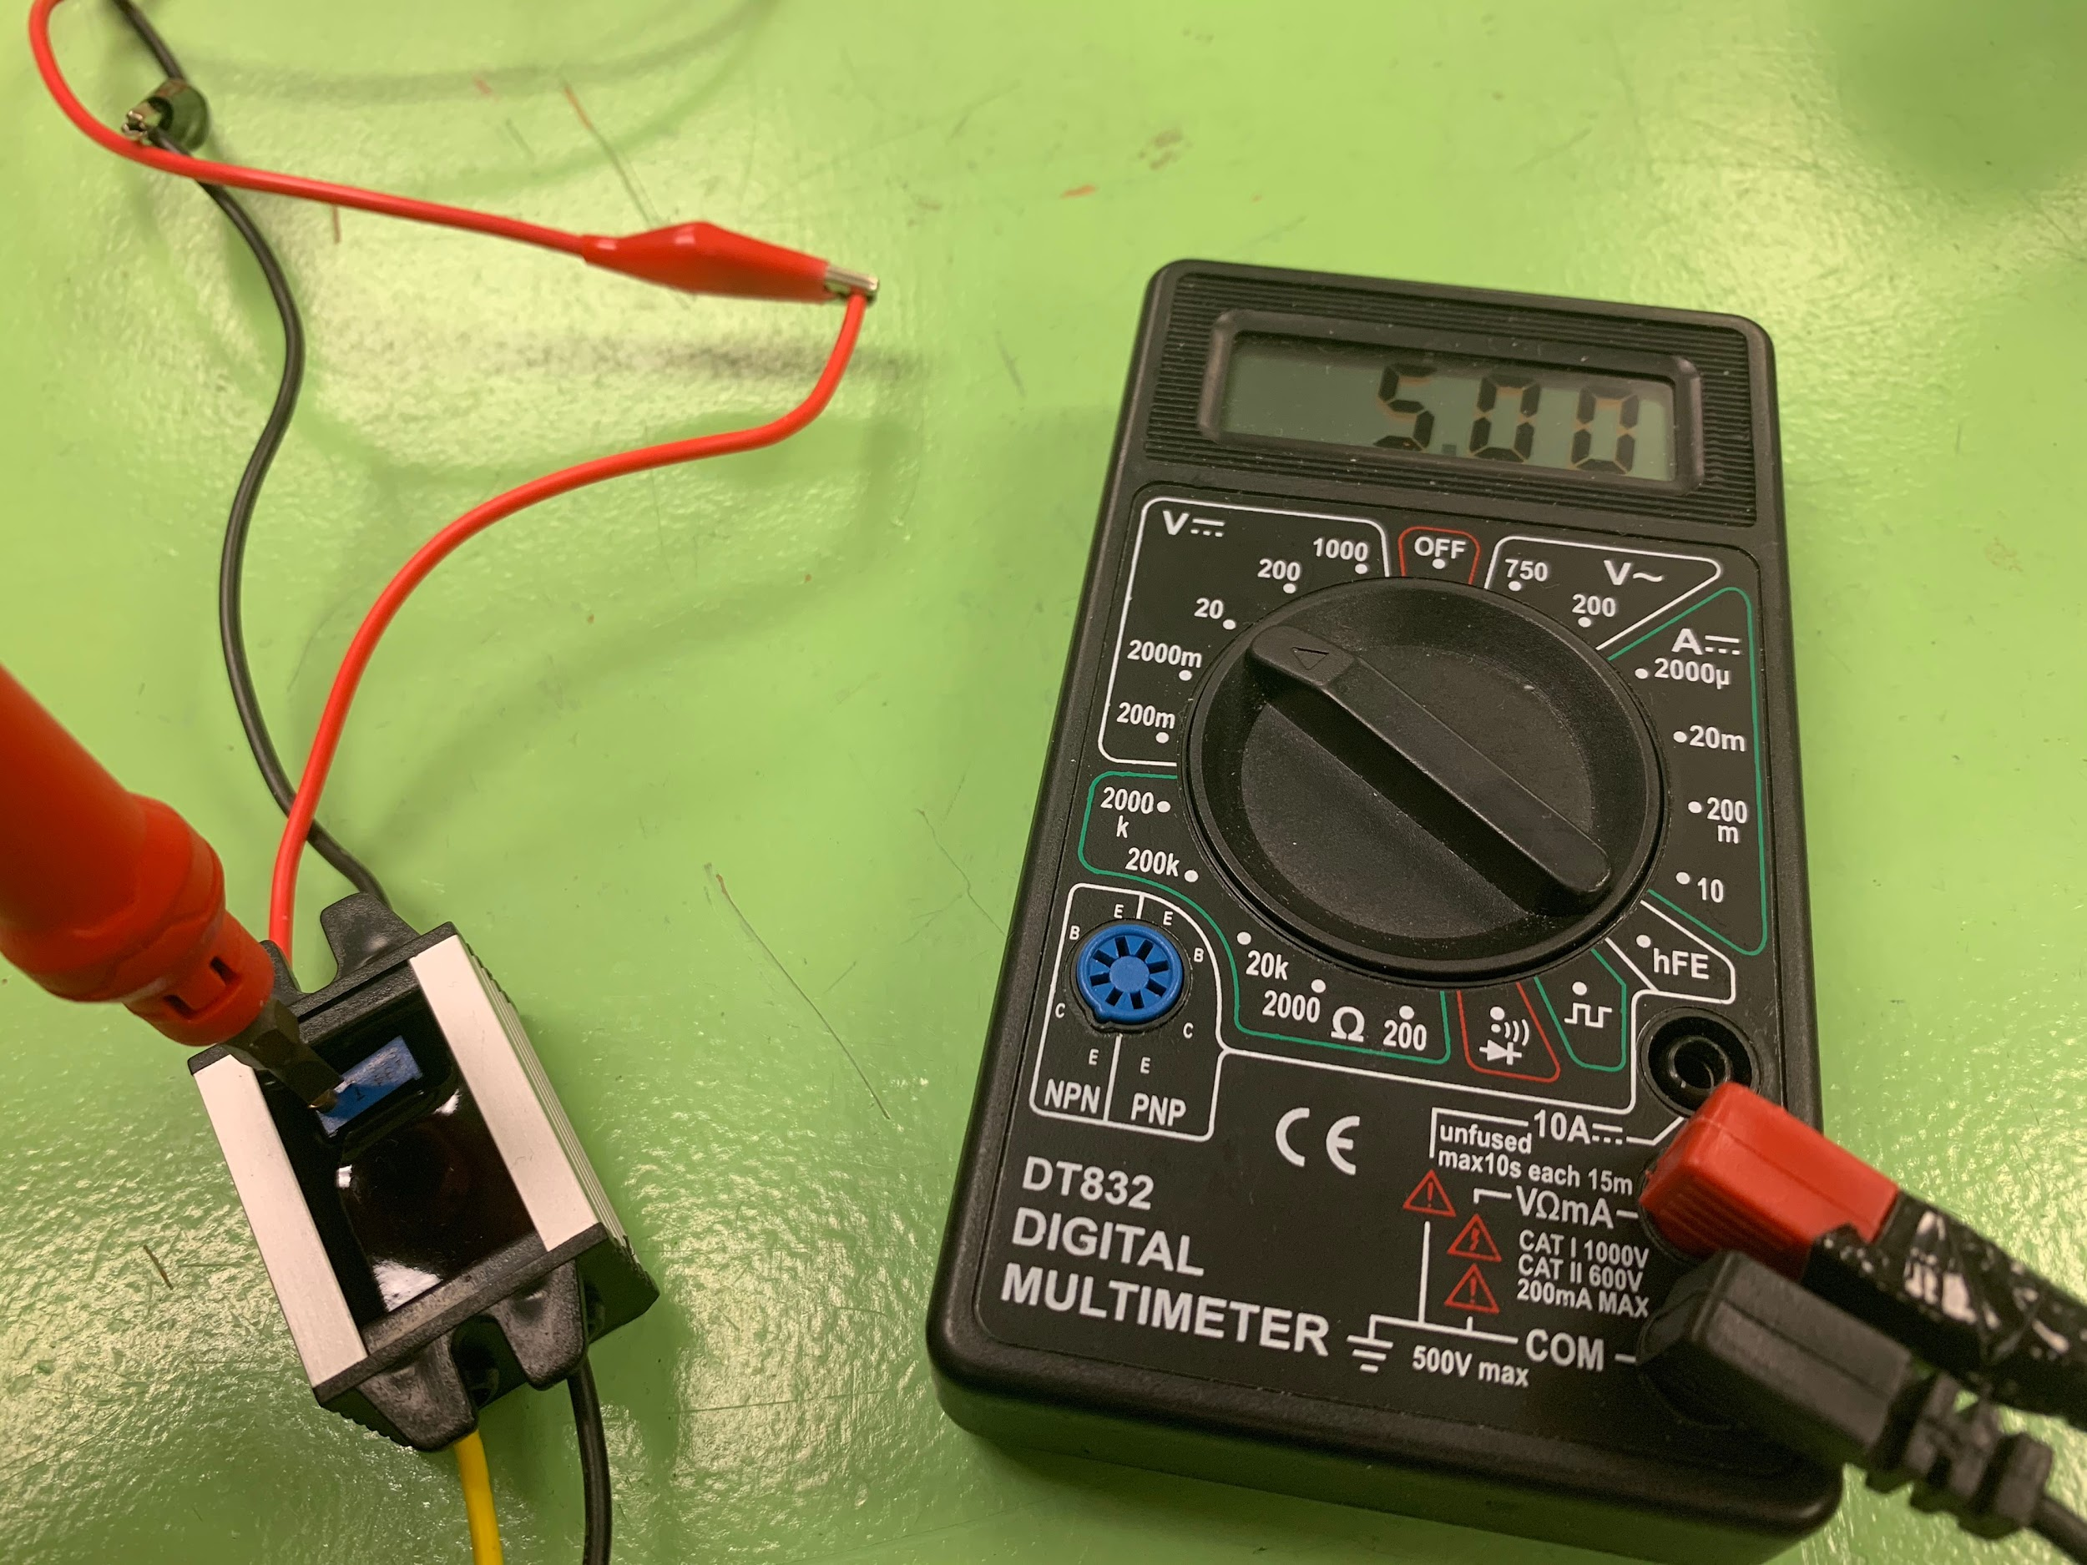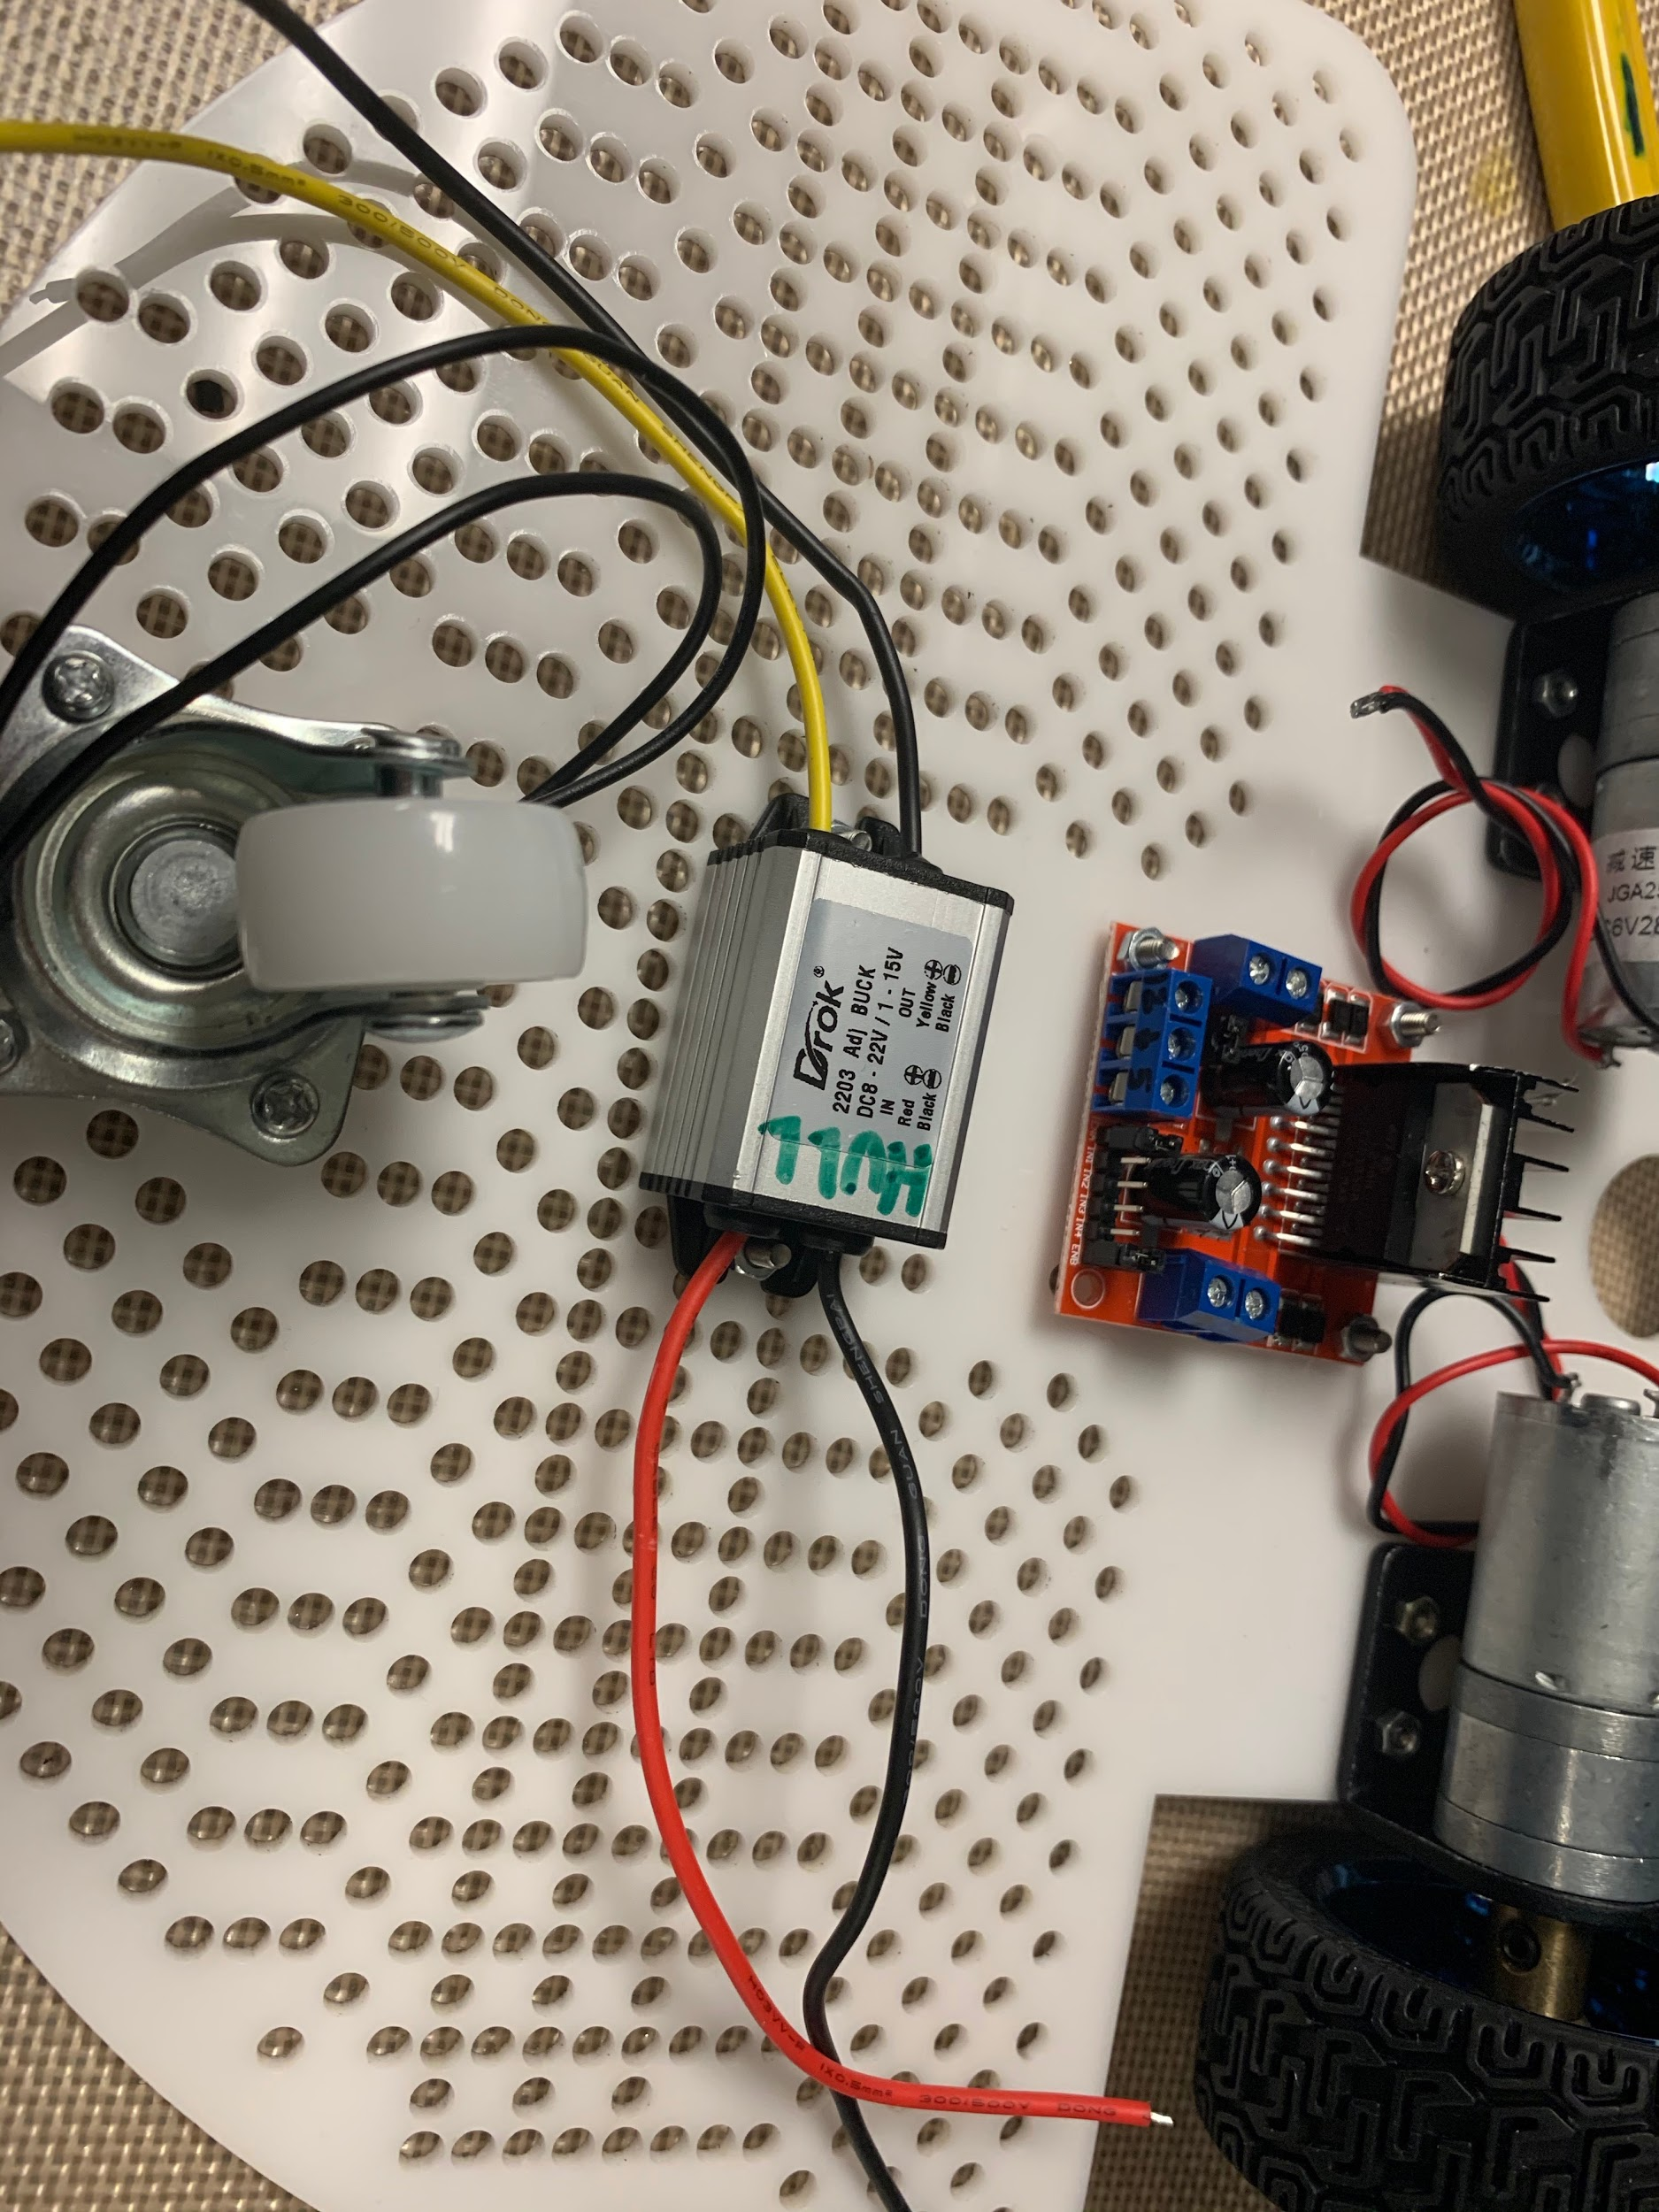

Use a small screwdriver to adjust the potentiometer until the output from the voltage regulator reads 5V. Then find a good spot to mount the voltage regulator to the base plate.

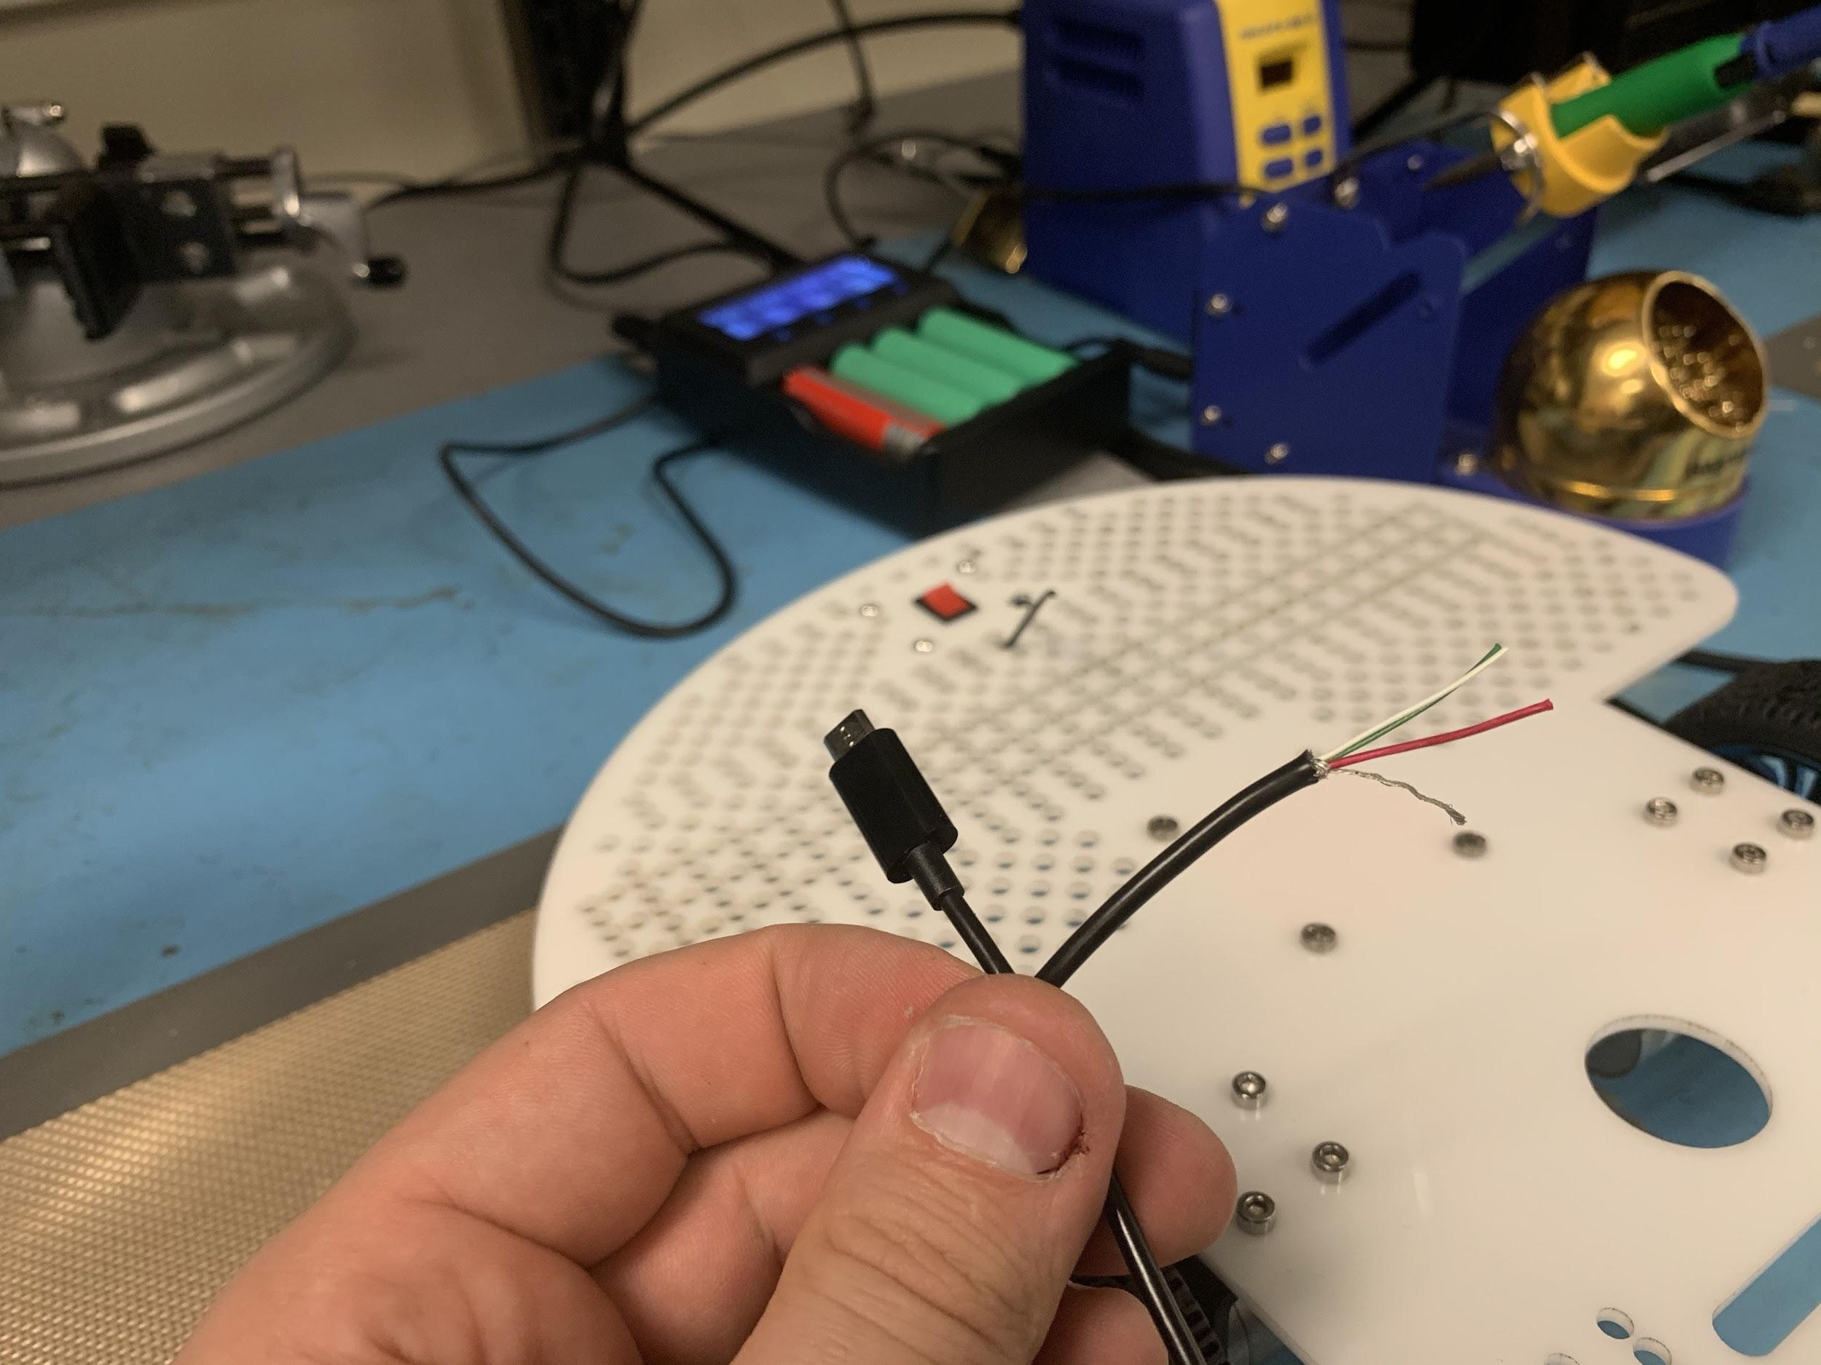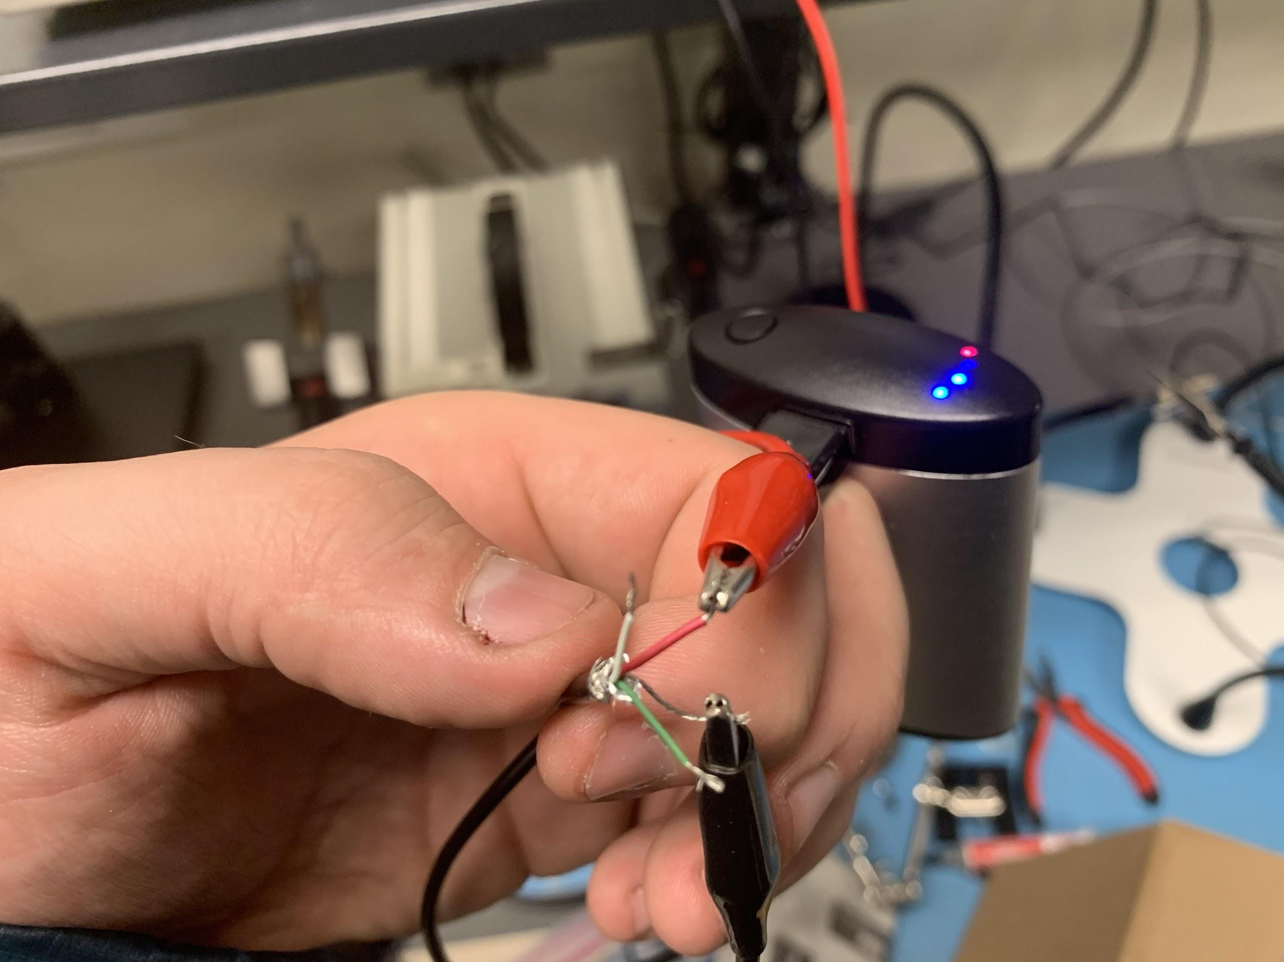

Next we need to make a power cable for our raspberry pi. We can use a cheap micro usb cable for this. There are two kinds, charge only charge and data. The charge only cables have 2 wires inside, while the charge and data cables have 4. We just need 2 wires for power, but if you have a 4 wire version, that’s okay too.

Clip the cable and strip the insulation back. Now we need to confirm that we have the correct colors for power. Take the USB side and plug it into a power bank. Carefully attach a multimeter to the wires you want to test. Here we’re connected to the red wire and the uninsulated wire to test for +V and -V. Test the output with a multimeter until you find the combination that gives you a positive voltage output on the display.

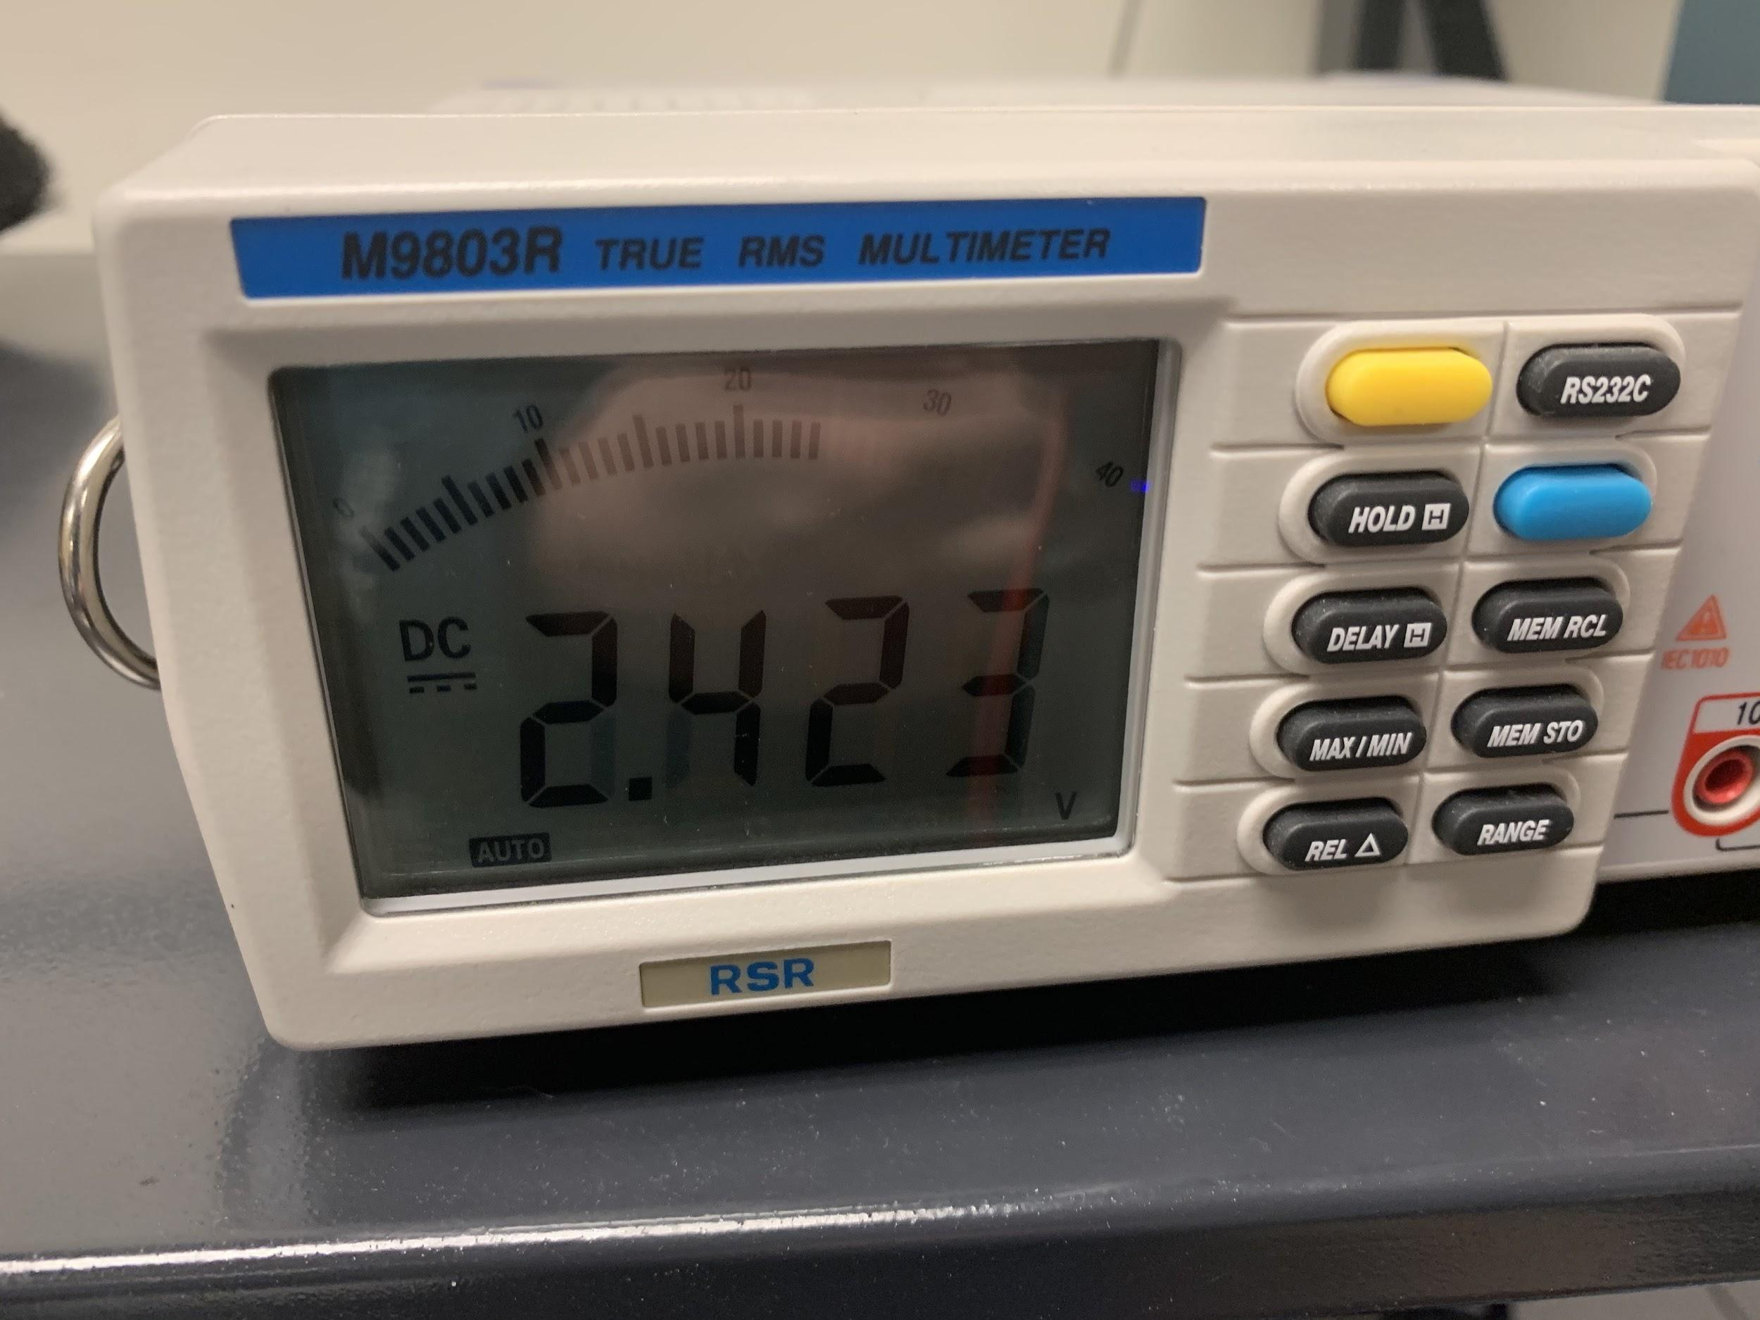

Here we can see that our output from the USB bank is a positive 2.4V. (It needed charged) This means that the red wire in our cable is +V and the uninsulated wire is -V.

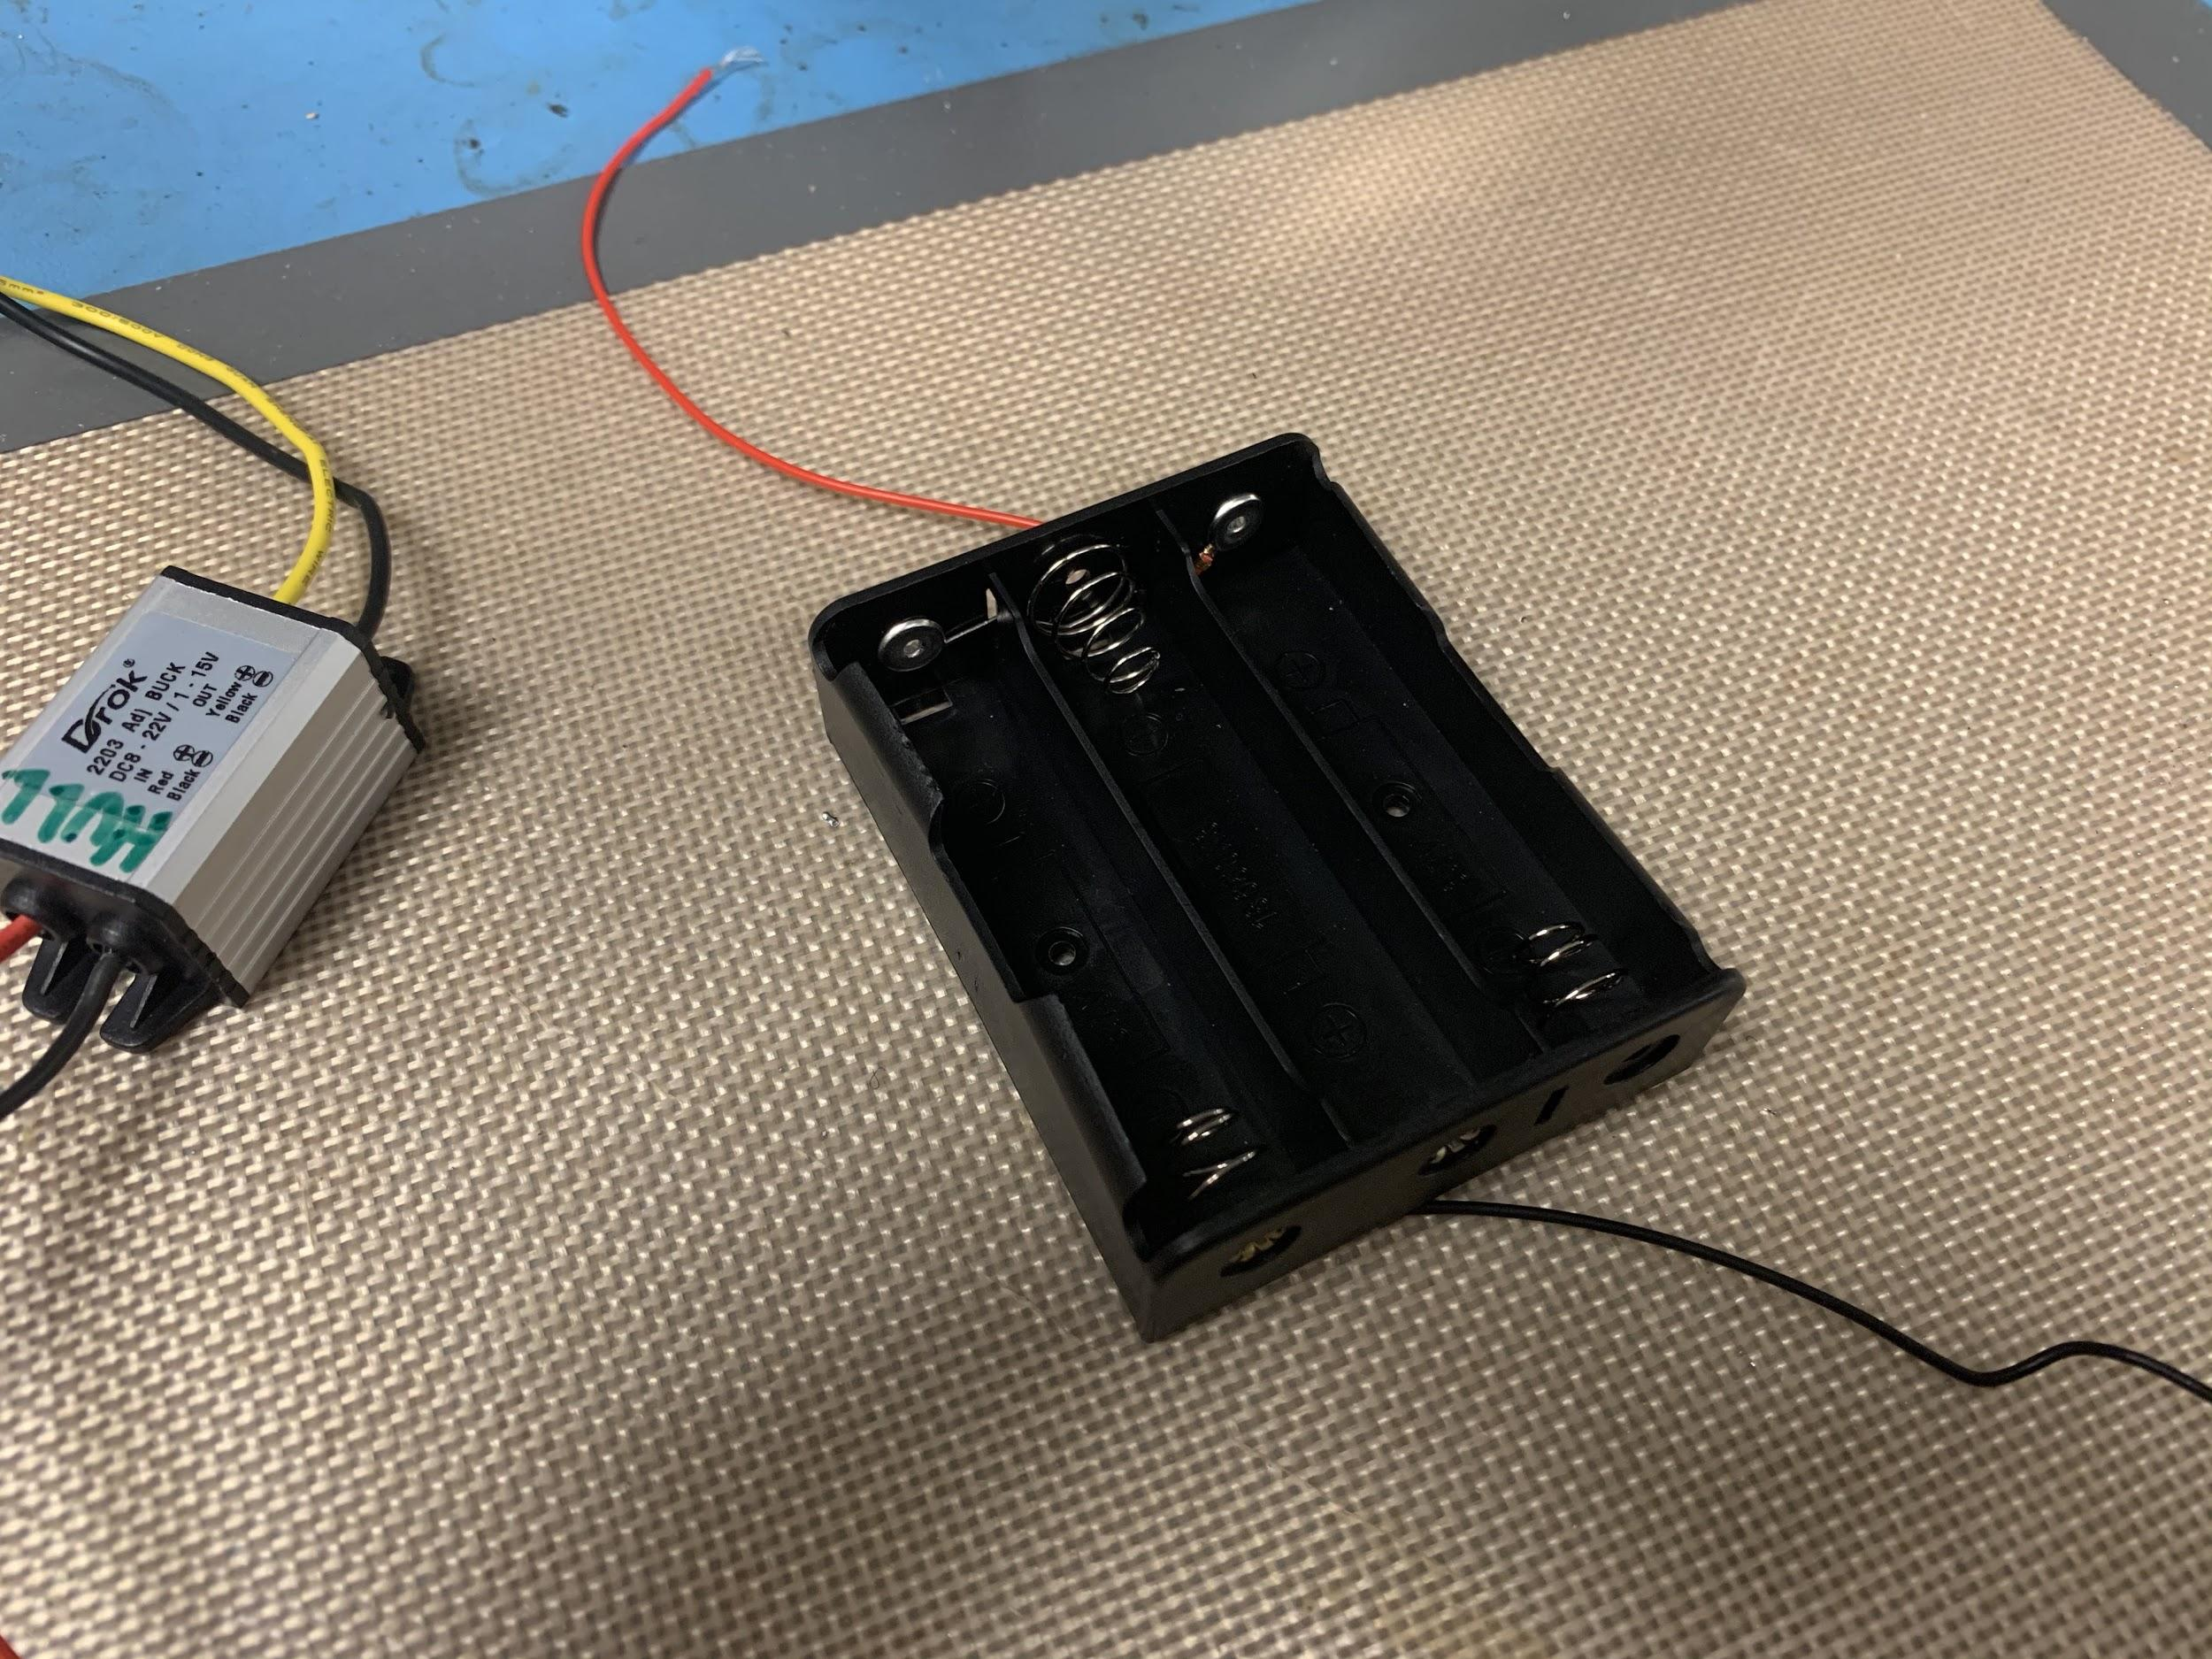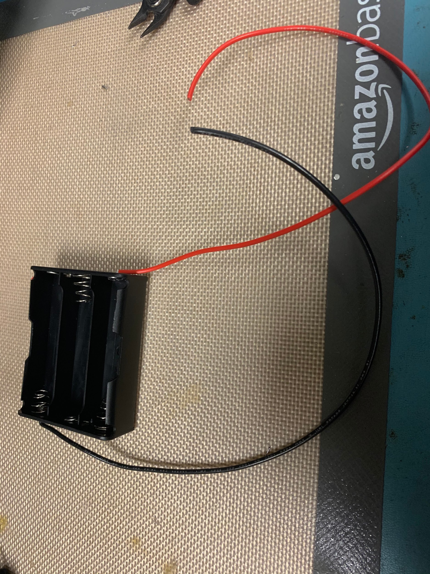

Now let’s make a modification to our battery packs. They come with wire a little too thin for handling 2.5 amps. We removed the thin wire and added some thicker wire. Just solder the new wire to the metal connections in the battery pack. Just be careful not to get the contacts to hot and melt the plastic of the battery pack.

Next, let’s take a look at the schematic to start getting all our wiring hooked up correctly.

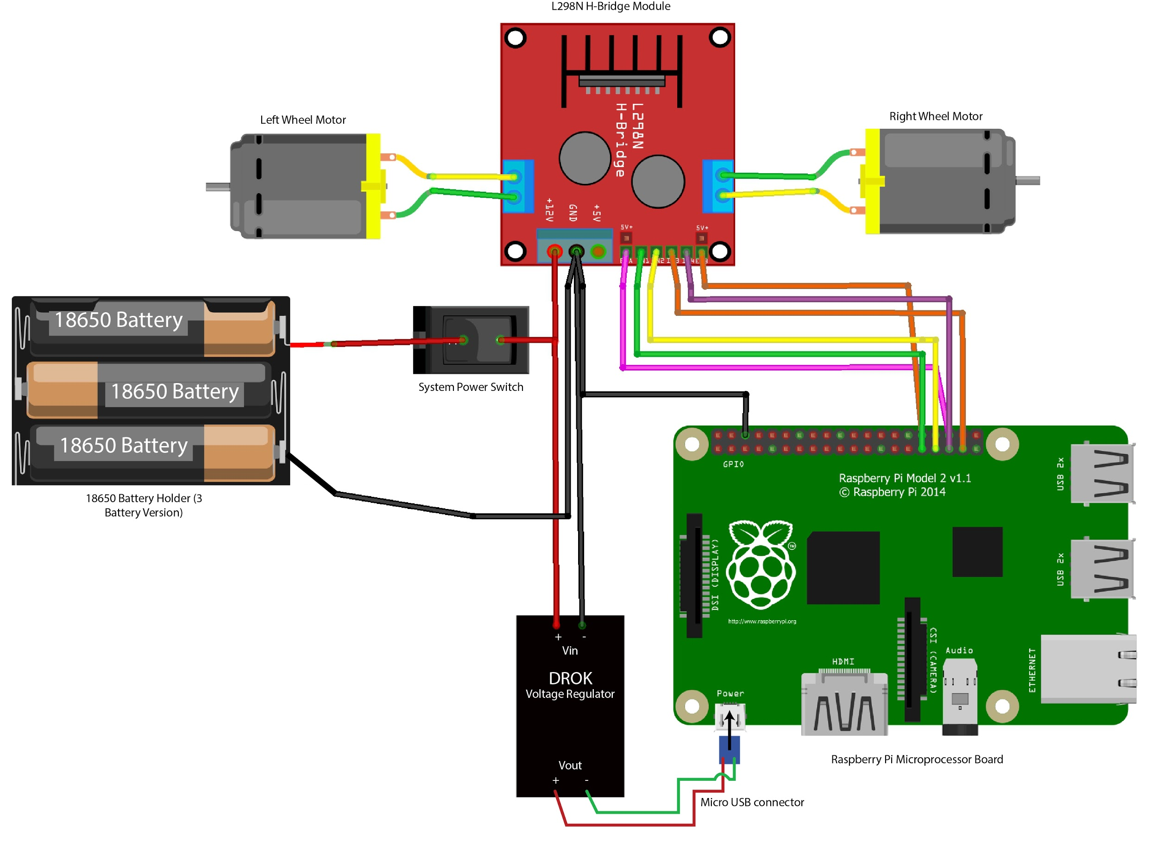

Start hooking up the wiring following the diagram above. Here we picture the switch connected to the positive wire from the battery, but we connect it to the negative wire in our photos. Either way will work to disconnect power from the battery pack.

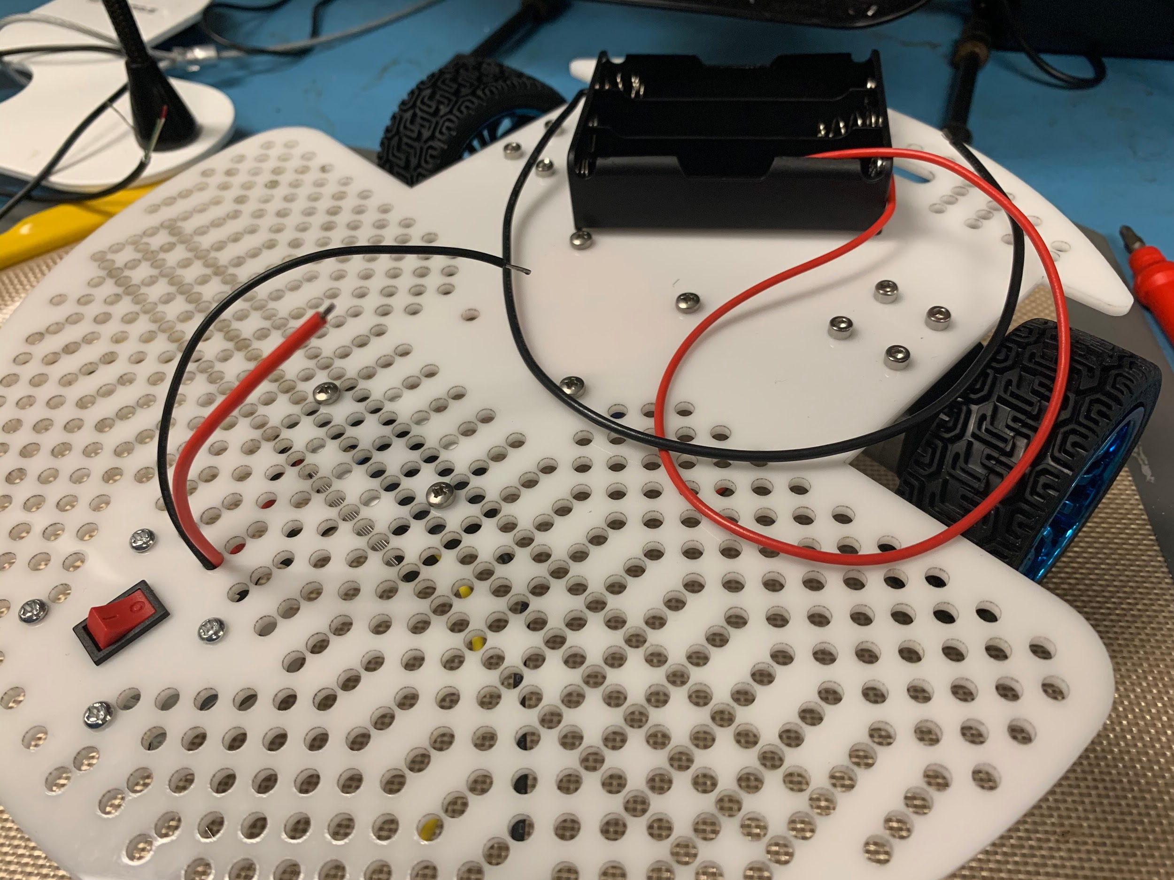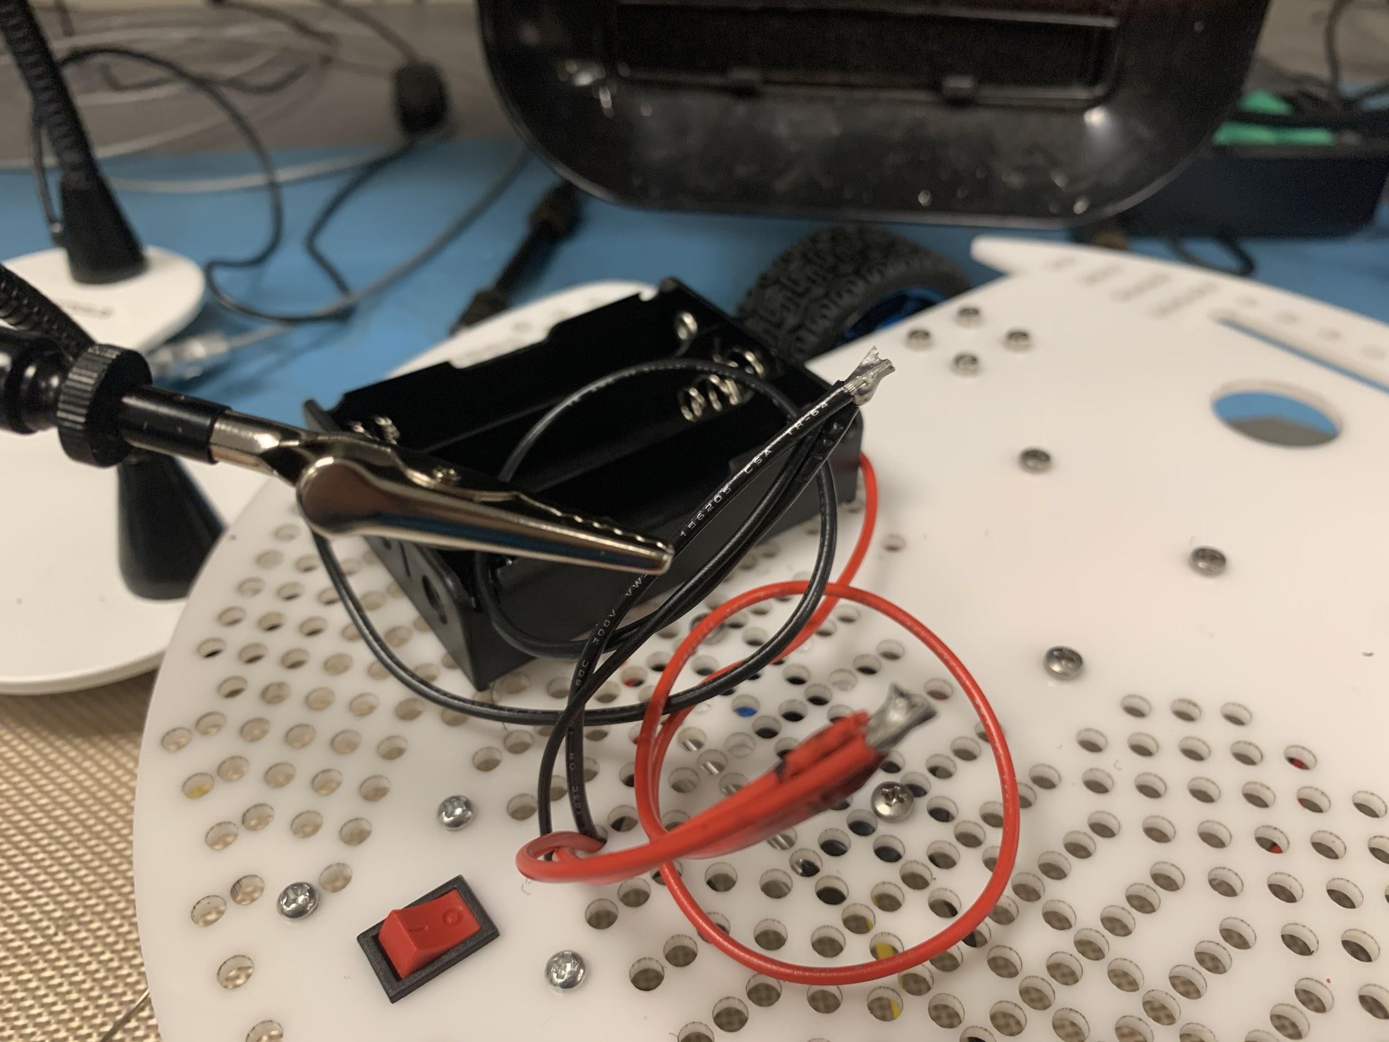

Run the input wires from the voltage regulator up through base plate and solder them to the wires from your battery pack. Solder them together to make a junction. We just soldered the wires we used directly together but you could also use a terminal block if you’re feeling fancy. (Actually, this would be a much better idea and we recommend it)

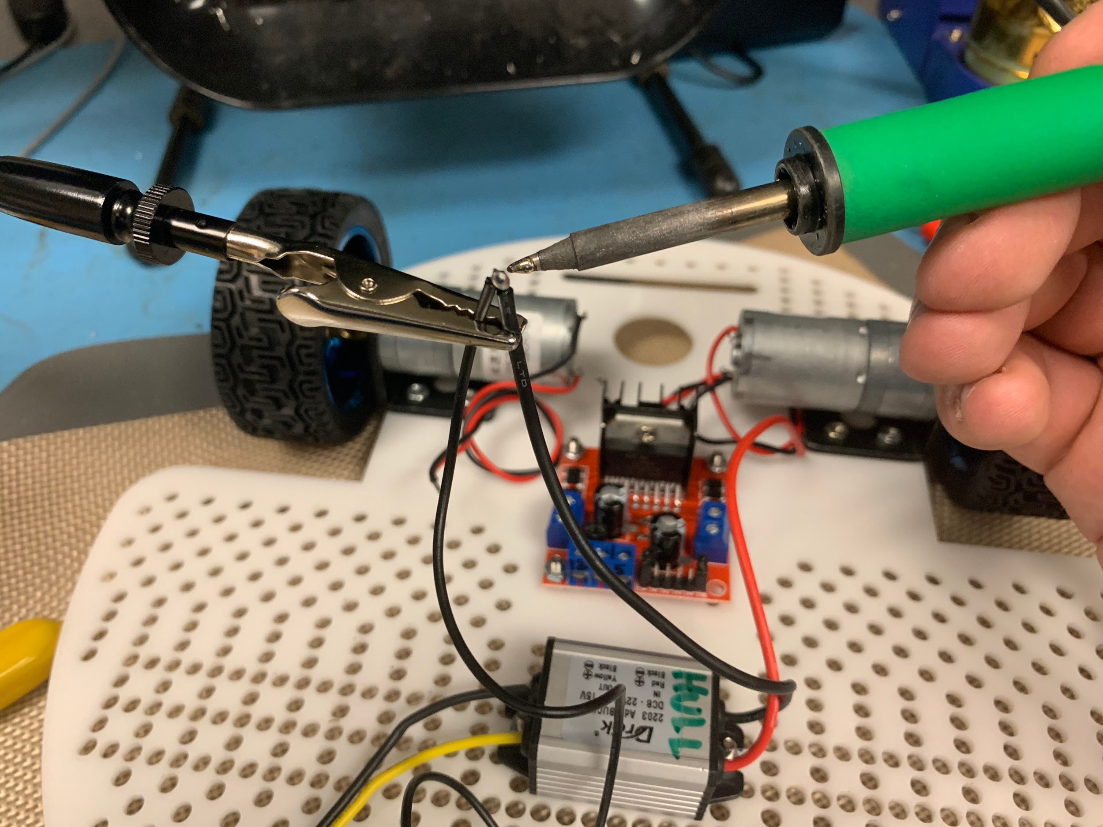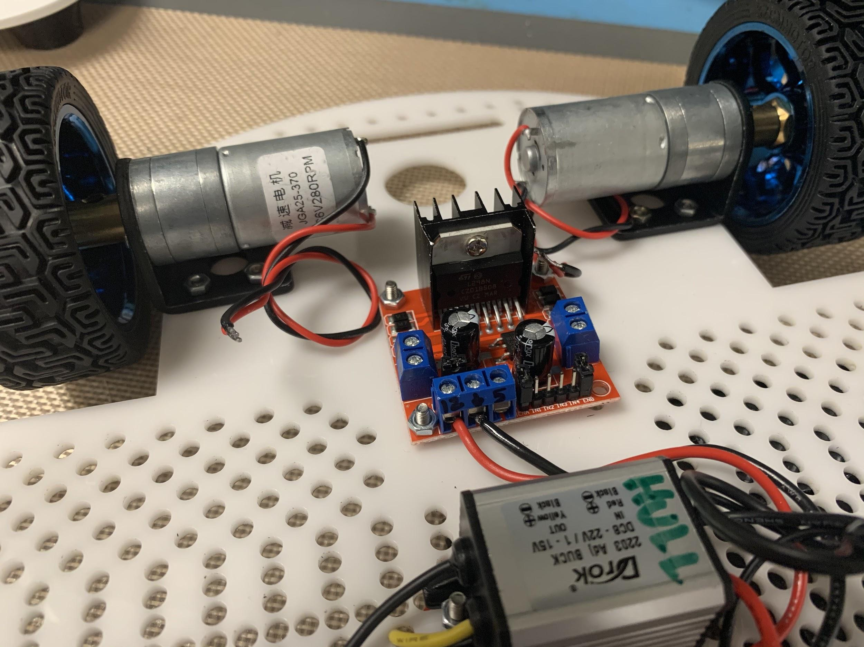

Solder up some more connections and run wires to your motor controller. Make sure to connect the wires from your battery pack to the 12V and GND connections on the motor controller board.

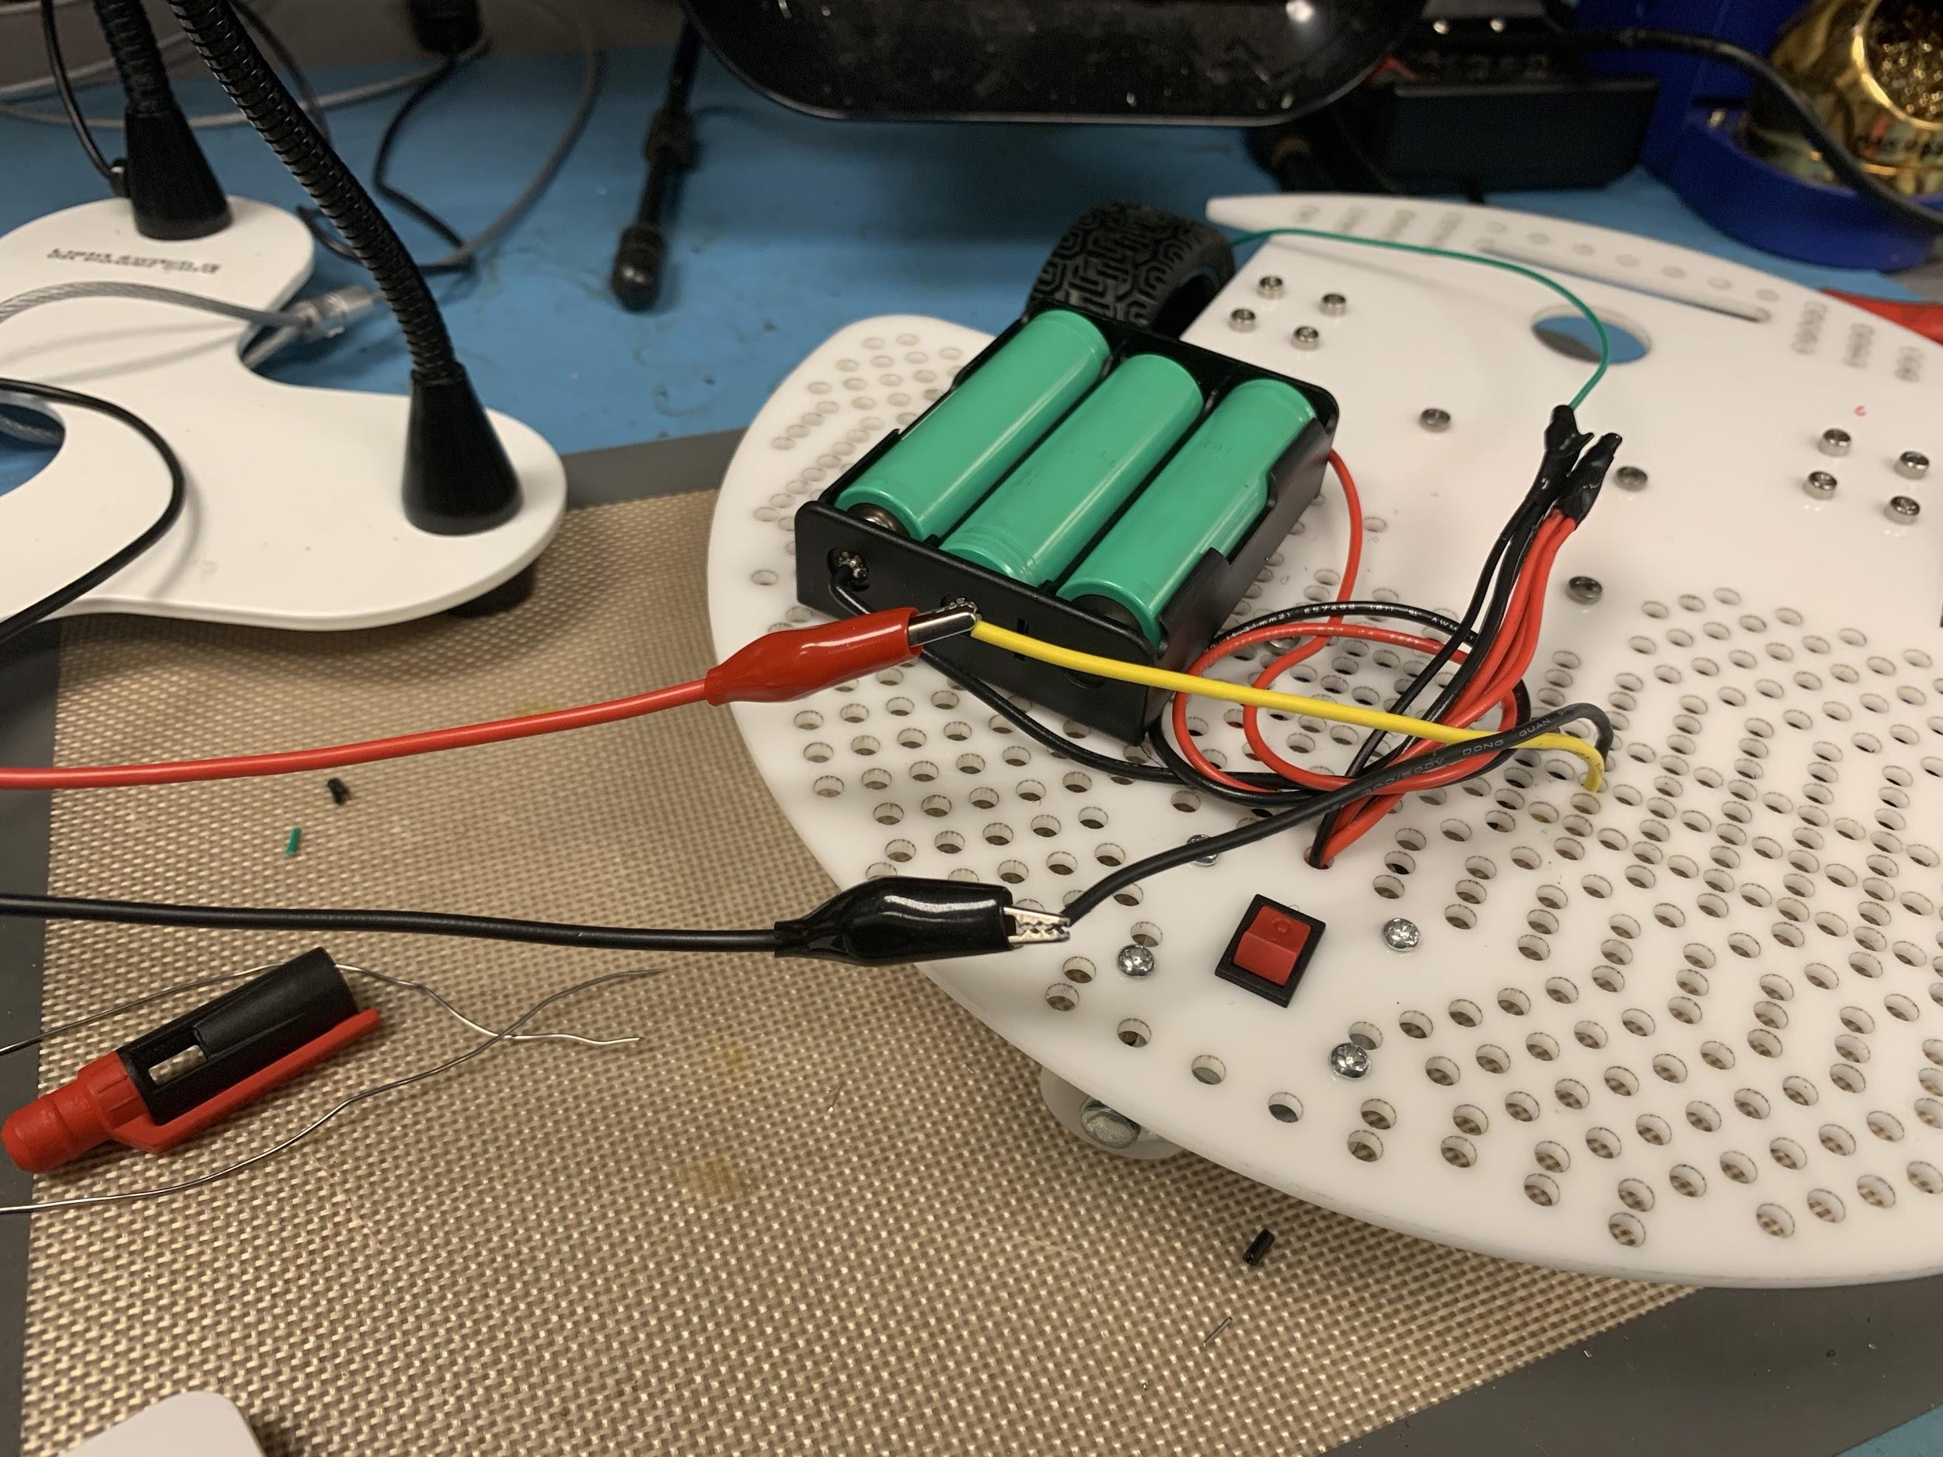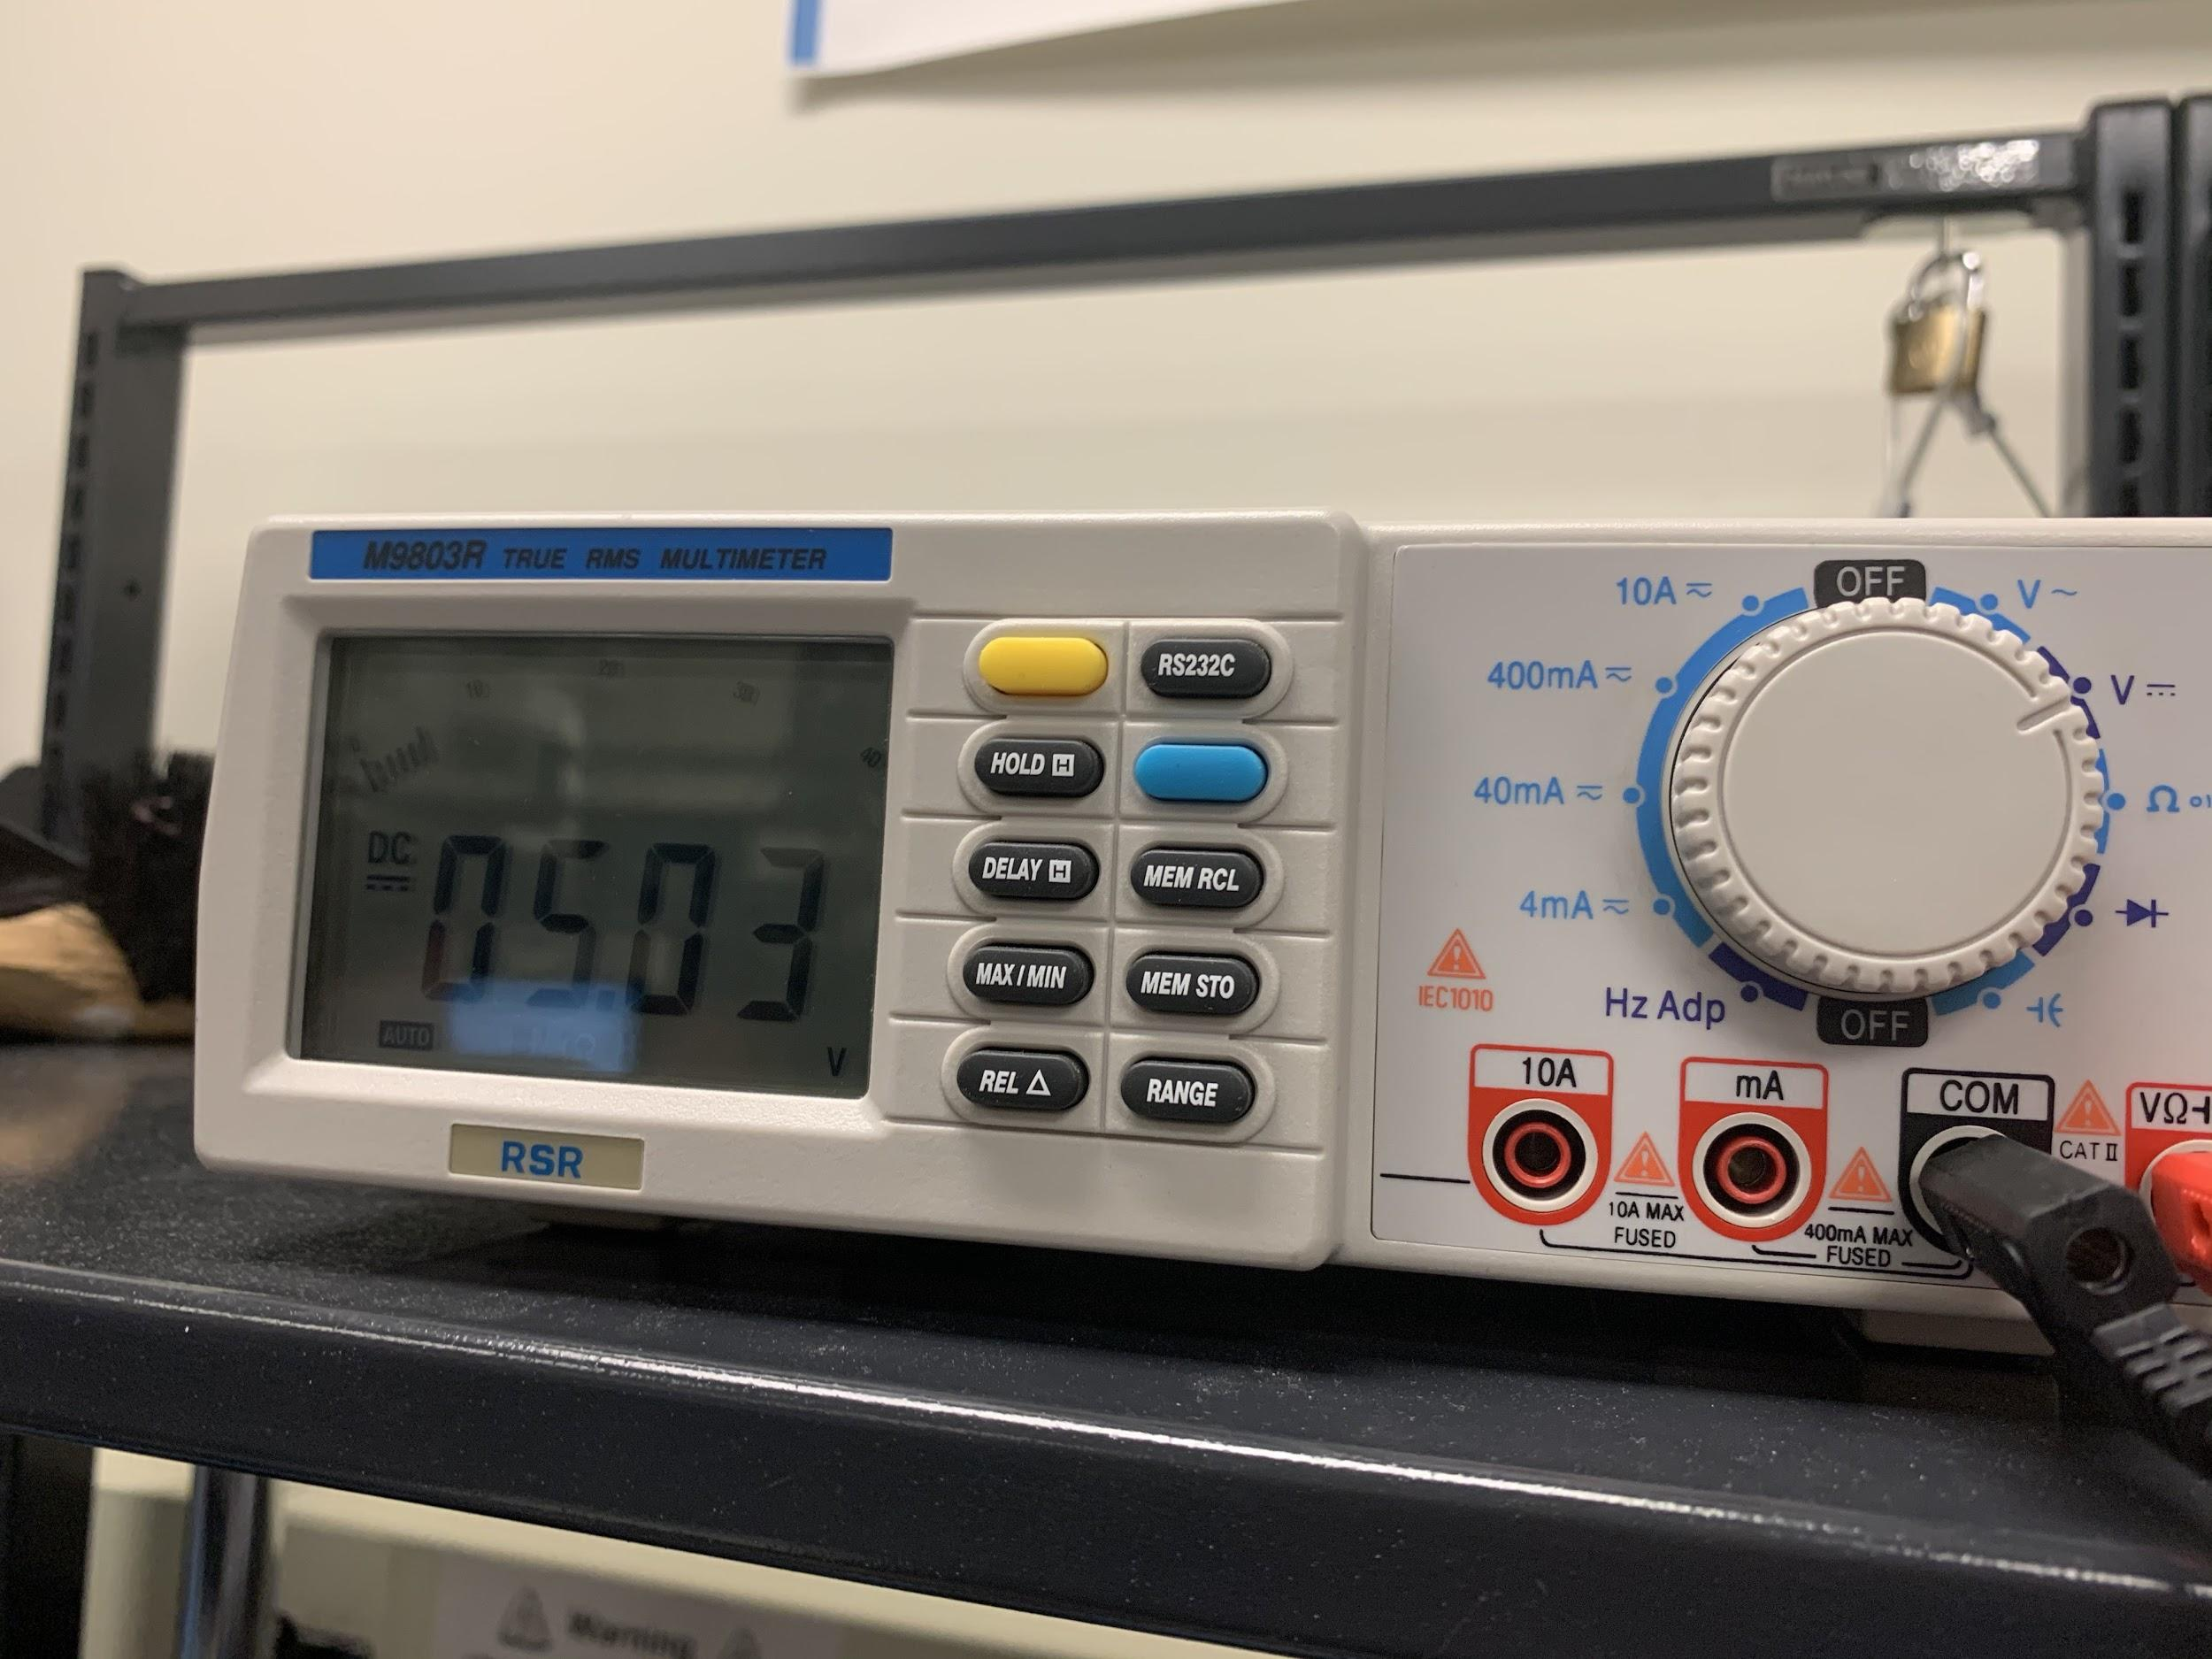

Before we hook up our micro USB cable to the raspberry pi, let’s make sure that it’s outputting the correct voltage after being hooked up to our 12V battery pack. Connect to the output wires from the voltage regulator one more time and check the output on a multimeter. If you’re still close to 5V, then you’re good to go. Otherwise, make sure to adjust the potentiometer on the voltage regulator until you get back to 5V.

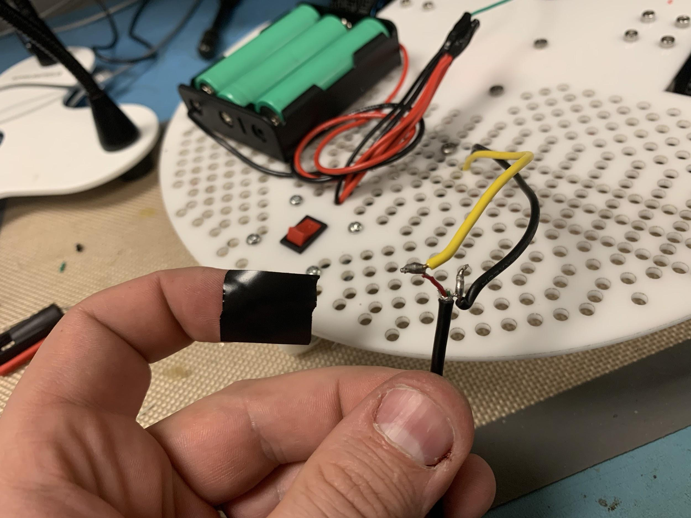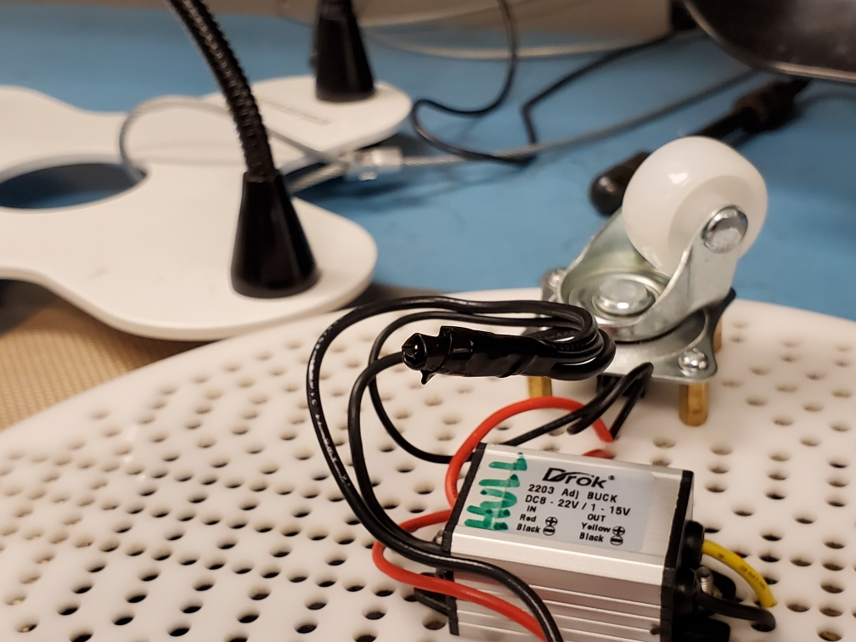

Now that we’ve tested the output from the regulator again, go ahead and solder the micro USB cable to the regulator output. This will let the raspberry pi pull as much power as it needs directly from the batteries. Add some electrical tape when you’re done to keep the connections from shorting out.

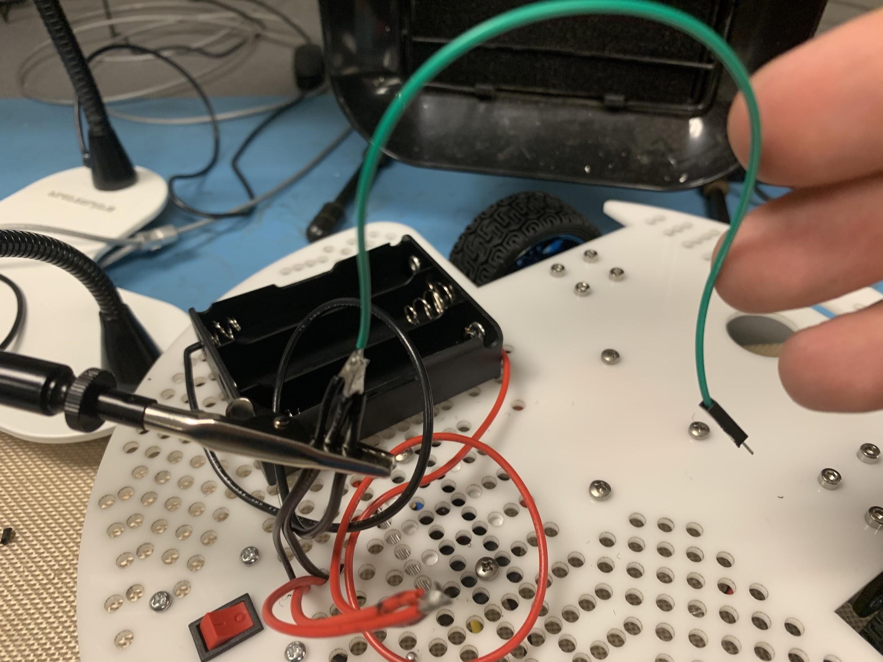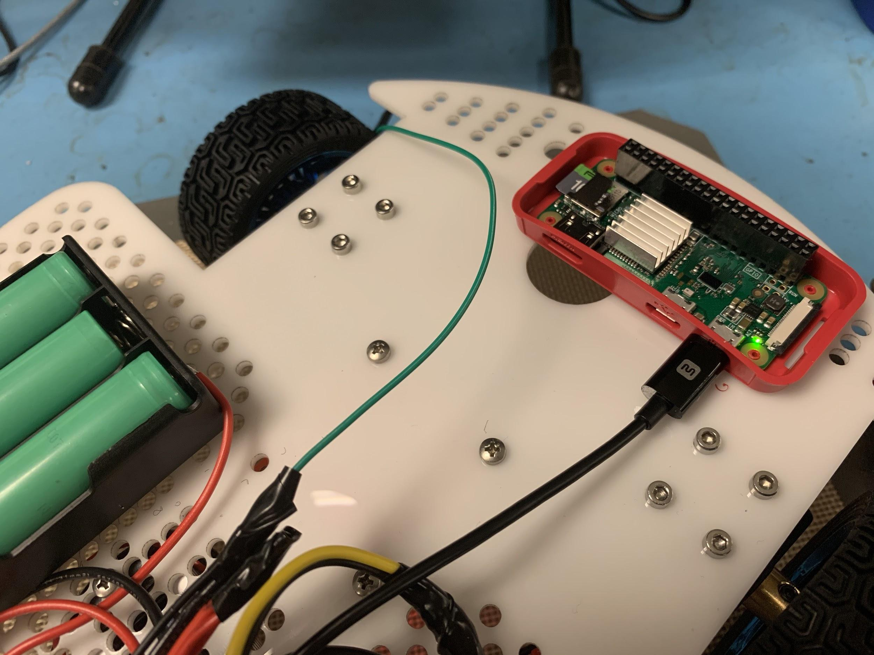

Back on top, make sure you add a ground wire to connect to the ground pin of the raspberry pi. This connects the ground for the GPIO pins that are sending control signals to the motor controller board. Double check that the micro USB can power on the pi and it boots up.

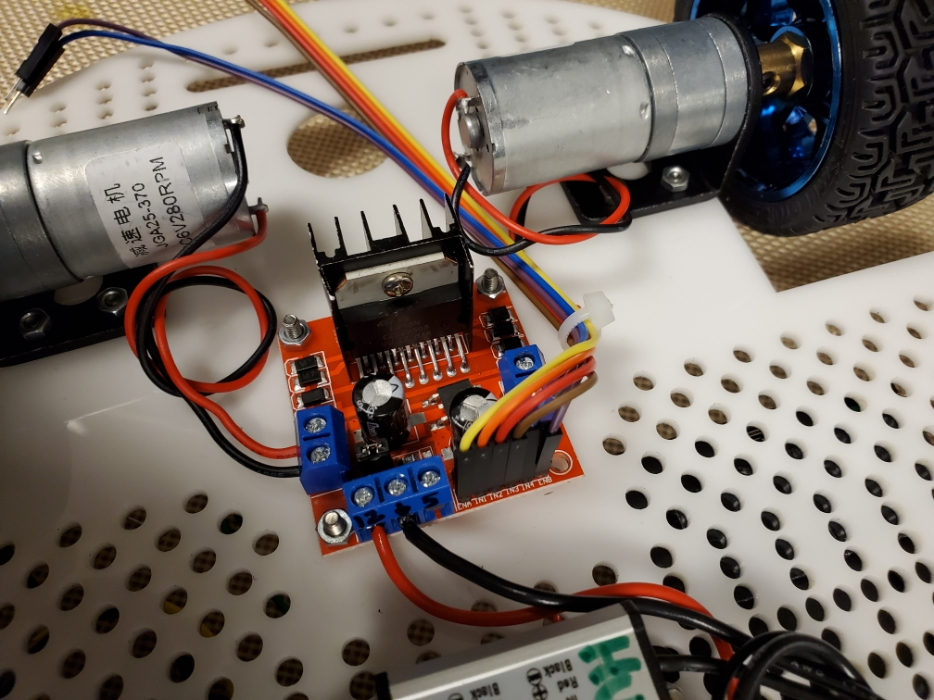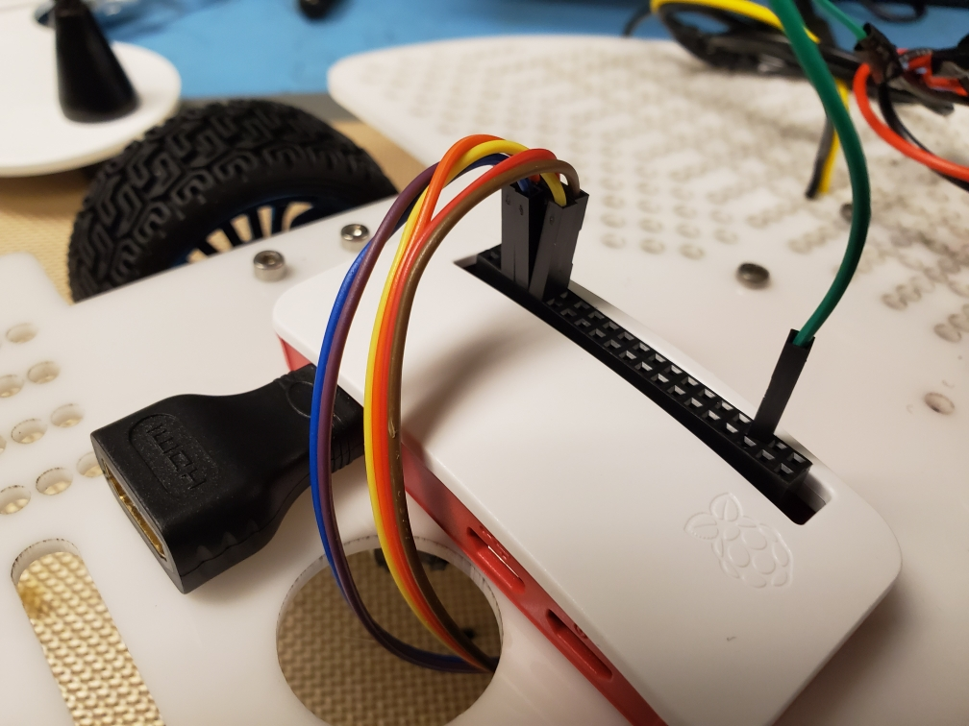

Now let’s connect all our jumper wires from the motor controller board to the GPIO pins on the raspberry pi. Add some velcro or tape to the raspberry pi and mount it to the deck making sure you can access the hdmi and data ports in case you need to connect a monitor.

**You’re All Done**

Now you’ve finished putting together your updated viking bot and it’s time to start programming! We’ve put together a few python scripts to help you get started driving your viking bot around. You can find them on our GitHub page at: <https://github.com/mmayers88/Robotics>